# Introduction

In our exploration of ecological dynamics, our group aims to construct a logistics model of predator-prey and discover how the dynamics of this system would change with some restrictions. The model incorporates key parameters such as the intrinsic growth rate of prey, the rate of prey consumption by predators, the death rate of predators, and the rate at which prey contribute to predator reproduction. To unravel the mathematical intricacies of the predator-prey relationship and also gain valuable insights, our project is focused on three main tasks: investigating Runge-Kutta methods and coding them in Python, constructing a simple system with exponential growth for both the prey and predator population, and modifying our system to have logistic growth for the prey population only. Doing this would offer us a quantitative lens to better understand the delicate balance that sustains and regulates these complex ecosystems from both ecological and mathematical perspectives.

# Runge-Kutta Methods

In order to calculate the change in population in the predator-prey model, our team looked into three different Runge-Kutta methods. Specifically, we investigated Euler’s Method, Heun’s Method and Explicit Midpoint Method.

## Euler’s Method

Euler's method is a first order Runge–Kutta method used to approximate solutions to ordinary differential equations (ODEs). Given an initial point <math xmlns="http://www.w3.org/1998/Math/MathML" display="block" data-is-equatio="1" data-latex="(x_0, y_0)"><mo stretchy="false">(</mo><msub><mi>x</mi><mn>0</mn></msub><mo>,</mo><msub><mi>y</mi><mn>0</mn></msub><mo stretchy="false">)</mo></math>, it approximates the solution at a target -value using a step-size. It does this by using the tangent to the curve at the initial point to determine the next point.

The formula is:

<math xmlns="http://www.w3.org/1998/Math/MathML" display="block" data-is-equatio="1" data-latex="y_{n+1} = y_n + h * F(x_n,y_n)"><msub><mi>y</mi><mrow data-mjx-texclass="ORD"><mi>n</mi><mo>+</mo><mn>1</mn></mrow></msub><mo>=</mo><msub><mi>y</mi><mi>n</mi></msub><mo>+</mo><mi>h</mi><mo>∗</mo><mi>F</mi><mo stretchy="false">(</mo><msub><mi>x</mi><mi>n</mi></msub><mo>,</mo><msub><mi>y</mi><mi>n</mi></msub><mo stretchy="false">)</mo></math>

where <math xmlns="http://www.w3.org/1998/Math/MathML" display="block" data-is-equatio="1" data-latex="F(x_n,y_n)"><mi>F</mi><mo stretchy="false">(</mo><msub><mi>x</mi><mi>n</mi></msub><mo>,</mo><msub><mi>y</mi><mi>n</mi></msub><mo stretchy="false">)</mo></math> is the derivative/change of slope of the graph and ***h*** is step-size {Euler’s Method for Solving Initial Value Problems in Ordinary Differential Equations, 2012}.

## Heun's Method

Heun's method, which can also be referred to as modified Euler's method, is a second order Runge–Kutta method used to solve ODEs given an initial value. It is considered an improvement over Euler's as it takes the tangent on both sides of the curve, where one overestimates and the other underestimates the slope of the next point. The final approximation uses the average of the two slopes.

At each step, an intermediate value <math xmlns="http://www.w3.org/1998/Math/MathML" display="block" data-is-equatio="1" data-latex="\widetilde{y}_{n+1}"><msub><mrow data-mjx-texclass="ORD"><mover><mi>y</mi><mo>~</mo></mover></mrow><mrow data-mjx-texclass="ORD"><mi>n</mi><mo>+</mo><mn>1</mn></mrow></msub></math> has to be calculated where:



where <math xmlns="http://www.w3.org/1998/Math/MathML" display="block" data-is-equatio="1" data-latex="F(x_n,y_n)"><mi>F</mi><mo stretchy="false">(</mo><msub><mi>x</mi><mi>n</mi></msub><mo>,</mo><msub><mi>y</mi><mi>n</mi></msub><mo stretchy="false">)</mo></math> is the derivative/change of slope of the graph and  is the step-size.

To get the final approximation at each step:



where  and <math xmlns="http://www.w3.org/1998/Math/MathML" display="block" data-is-equatio="1" data-latex="h"><mi>h</mi></math> is the step-size {IMPROVING THE EFFICIENCY OF HEUN’S METHOD, 2010}.

## Explicit Midpoint Method

Similar to Heun's, the explicit midpoint method is a second order Runge-Kutta method for solving differential equations. It uses the midpoint between <math xmlns="http://www.w3.org/1998/Math/MathML" display="block" data-is-equatio="1" data-latex="x_n"><msub><mi>x</mi><mi>n</mi></msub></math> and <math xmlns="http://www.w3.org/1998/Math/MathML" display="block" data-is-equatio="1" data-latex="x_{n+1}"><msub><mi>x</mi><mrow data-mjx-texclass="ORD"><mi>n</mi><mo>+</mo><mn>1</mn></mrow></msub></math> to calculate the next -value

At each step:



where <math xmlns="http://www.w3.org/1998/Math/MathML" display="block" data-is-equatio="1" data-latex="F(x_n,y_n)"><mi>F</mi><mo stretchy="false">(</mo><msub><mi>x</mi><mi>n</mi></msub><mo>,</mo><msub><mi>y</mi><mi>n</mi></msub><mo stretchy="false">)</mo></math> is the derivative/change of slope of the graph and  is the step-size {New explicit and implicit “improved euler” methods for the integration of ordinary differential equations, 2001}.

# The Initial System

<math xmlns="http://www.w3.org/1998/Math/MathML" display="block" data-is-equatio="1" data-latex="\frac{dR}{dt}=k_r R -\mu_rRF"><mfrac><mrow><mi>d</mi><mi>R</mi></mrow><mrow><mi>d</mi><mi>t</mi></mrow></mfrac><mo>=</mo><msub><mi>k</mi><mi>r</mi></msub><mi>R</mi><mo>−</mo><msub><mi>μ</mi><mi>r</mi></msub><mi>R</mi><mi>F</mi></math>



We start with solving the predator-prey system (with a rabbit population <math xmlns="http://www.w3.org/1998/Math/MathML" display="block" data-is-equatio="1" data-latex="R"><mi>R</mi></math> and fox population  at time <math xmlns="http://www.w3.org/1998/Math/MathML" display="block" data-is-equatio="1" data-latex="t"><mi>t</mi></math> in years). The model consists of two equations, and <math xmlns="http://www.w3.org/1998/Math/MathML" display="block" data-is-equatio="1" data-latex="\frac{dF}{dt}"><mfrac><mrow><mi>d</mi><mi>F</mi></mrow><mrow><mi>d</mi><mi>t</mi></mrow></mfrac></math>, with a set of initial conditions for each population, <math xmlns="http://www.w3.org/1998/Math/MathML" display="block" data-is-equatio="1" data-latex="R(0)="><mi>R</mi><mo stretchy="false">(</mo><mn>0</mn><mo stretchy="false">)</mo><mo>=</mo></math><math xmlns="http://www.w3.org/1998/Math/MathML" display="block" data-is-equatio="1" data-latex="R_0"><msub><mi>R</mi><mn>0</mn></msub></math> and <math xmlns="http://www.w3.org/1998/Math/MathML" display="block" data-is-equatio="1" data-latex="F(0)="><mi>F</mi><mo stretchy="false">(</mo><mn>0</mn><mo stretchy="false">)</mo><mo>=</mo></math><math xmlns="http://www.w3.org/1998/Math/MathML" display="block" data-is-equatio="1" data-latex="F_0"><msub><mi>F</mi><mn>0</mn></msub></math>. These equations capture the basic dynamics of predator-prey interactions. As the prey population increases, it provides more food for the predators, causing the predator population to grow. Conversely, as the predator population increases, it puts more pressure on the prey population, leading to a decrease in prey growth. Aside from this, the model contains a total of four parameters:

* <math xmlns="http://www.w3.org/1998/Math/MathML" display="block" data-is-equatio="1" data-latex="k_r"><msub><mi>k</mi><mi>r</mi></msub></math> represents the natural survival rate of the rabbit population.
* <math xmlns="http://www.w3.org/1998/Math/MathML" display="block" data-is-equatio="1" data-latex="\mu_f"><msub><mi>μ</mi><mi>f</mi></msub></math> represents the natural survival rate of the fox population
*  represents the effect of the interaction between rabbits and foxes for the rabbit population.
* represents the effect of the interaction between rabbits and foxes for the fox population

## System under Different Scenarios

To analyze and understand our system better, we made different sets of parameters, each with their own restrictions on <math xmlns="http://www.w3.org/1998/Math/MathML" display="block" data-is-equatio="1" data-latex="k_r"><msub><mi>k</mi><mi>r</mi></msub></math>,<math xmlns="http://www.w3.org/1998/Math/MathML" display="block" data-is-equatio="1" data-latex="\mu_f"><msub><mi>μ</mi><mi>f</mi></msub></math>, , and . With help of Python plotting libraries, we were able to model three different scenarios found below to see the dynamics of our population system, which are

### <math xmlns="http://www.w3.org/1998/Math/MathML" display="block" data-is-equatio="1" data-latex="k_r&gt;0"><msub><mi>k</mi><mi>r</mi></msub><mo>&gt;</mo><mn>0</mn></math> and <math xmlns="http://www.w3.org/1998/Math/MathML" display="block" data-is-equatio="1" data-latex="\mu_r=0"><msub><mi>μ</mi><mi>r</mi></msub><mo>=</mo><mn>0</mn></math>

This yields the general solution for the prey population as <math xmlns="http://www.w3.org/1998/Math/MathML" display="block" data-is-equatio="1" data-latex="R(t) = R_0e^{k_rt}"><mi>R</mi><mo stretchy="false">(</mo><mi>t</mi><mo stretchy="false">)</mo><mo>=</mo><msub><mi>R</mi><mn>0</mn></msub><msup><mi>e</mi><mrow data-mjx-texclass="ORD"><msub><mi>k</mi><mi>r</mi></msub><mi>t</mi></mrow></msup></math>. Below are examples of the change in prey population given different values of <math xmlns="http://www.w3.org/1998/Math/MathML" display="block" data-is-equatio="1" data-latex="k_r"><msub><mi>k</mi><mi>r</mi></msub></math> for a specific <math xmlns="http://www.w3.org/1998/Math/MathML" display="block" data-is-equatio="1" data-latex="R_0"><msub><mi>R</mi><mn>0</mn></msub></math>.

For <math xmlns="http://www.w3.org/1998/Math/MathML" display="block" data-is-equatio="1" data-latex="k_r = 2"><msub><mi>k</mi><mi>r</mi></msub><mo>=</mo><mn>2</mn></math> and <math xmlns="http://www.w3.org/1998/Math/MathML" display="block" data-is-equatio="1" data-latex="R_0 = 10"><msub><mi>R</mi><mn>0</mn></msub><mo>=</mo><mn>10</mn></math>:

[Figure\_1](#rppxhd7x3gy6)

For  and <math xmlns="http://www.w3.org/1998/Math/MathML" display="block" data-is-equatio="1" data-latex="R_0 = 10"><msub><mi>R</mi><mn>0</mn></msub><mo>=</mo><mn>10</mn></math>:

[Figure\_2](#7rc4wpgqmbbc)

As we can see, under ideal conditions (i.e. no interaction with predators), the prey population will increase exponentially since there are no predators that would be using the prey as their food source. Additionally, this growth would be without any limit since there is no carrying capacity to limit the prey population. Another thing that can be noted is that when  is kept constant and <math xmlns="http://www.w3.org/1998/Math/MathML" display="block" data-is-equatio="1" data-latex="k_r"><msub><mi>k</mi><mi>r</mi></msub></math> increases, the rabbit population grows faster in the same amount of time.

### <math xmlns="http://www.w3.org/1998/Math/MathML" display="block" data-is-equatio="1" data-latex="k_f&gt;0"><msub><mi>k</mi><mi>f</mi></msub><mo>&gt;</mo><mn>0</mn></math> and mu sub f equals 0

This yields the general solution for the predator population as <math xmlns="http://www.w3.org/1998/Math/MathML" display="block" data-is-equatio="1" data-latex="F(t) = F_0e^{-k_ft}"><mi>F</mi><mo stretchy="false">(</mo><mi>t</mi><mo stretchy="false">)</mo><mo>=</mo><msub><mi>F</mi><mn>0</mn></msub><msup><mi>e</mi><mrow data-mjx-texclass="ORD"><mo>−</mo><msub><mi>k</mi><mi>f</mi></msub><mi>t</mi></mrow></msup></math>.

Below are examples of the change in prey population given different values of <math xmlns="http://www.w3.org/1998/Math/MathML" display="block" data-is-equatio="1" data-latex="k_f"><msub><mi>k</mi><mi>f</mi></msub></math> for a specific .

For <math xmlns="http://www.w3.org/1998/Math/MathML" display="block" data-is-equatio="1" data-latex="F_0 = 10"><msub><mi>F</mi><mn>0</mn></msub><mo>=</mo><mn>10</mn></math> and :

[Figure\_3](#9zjzkyldna3e)

For <math xmlns="http://www.w3.org/1998/Math/MathML" display="block" data-is-equatio="1" data-latex="F_0 = 10"><msub><mi>F</mi><mn>0</mn></msub><mo>=</mo><mn>10</mn></math> and :

[Figure\_4](#3rb9iubkw0vs)

We can see that predators experience a natural mortality in the absence of prey consumption. Without their food source, the predators are not able to survive, causing their population to die off until there is no one remaining. Additionally, it can be noted that when  is kept constant and <math xmlns="http://www.w3.org/1998/Math/MathML" display="block" data-is-equatio="1" data-latex="k_f"><msub><mi>k</mi><mi>f</mi></msub></math> increases, the fox population decreases faster in the same amount of time.

### <math xmlns="http://www.w3.org/1998/Math/MathML" display="block" data-is-equatio="1" data-latex="k_r&lt;0"><msub><mi>k</mi><mi>r</mi></msub><mo>&lt;</mo><mn>0</mn></math> and <math xmlns="http://www.w3.org/1998/Math/MathML" display="block" data-is-equatio="1" data-latex="k_f&lt;0"><msub><mi>k</mi><mi>f</mi></msub><mo>&lt;</mo><mn>0</mn></math>

This represents an unconventional and potentially unstable set of dynamics. If <math xmlns="http://www.w3.org/1998/Math/MathML" display="block" data-is-equatio="1" data-latex="k_r&lt;0"><msub><mi>k</mi><mi>r</mi></msub><mo>&lt;</mo><mn>0</mn></math>, then the rabbit population would naturally decrease instead of increase. Similarly, if <math xmlns="http://www.w3.org/1998/Math/MathML" display="block" data-is-equatio="1" data-latex="k_f&lt;0"><msub><mi>k</mi><mi>f</mi></msub><mo>&lt;</mo><mn>0</mn></math>, then the fox population would naturally increase instead of decrease. The benefit of choosing positive values for the parameters is the fact that they make more sense biologically. Without the interaction of rabbits and foxes, the rabbit population should naturally increase and the fox population should naturally decrease since they are not getting their food source.

## Trivial and Non-Trivial Equilibrium Solutions and its Dynamics According to the Jacobian Matrix

<math xmlns="http://www.w3.org/1998/Math/MathML" display="block" data-is-equatio="1" data-latex="\frac{dR}{dt}=k_r R -\mu_rRF"><mfrac><mrow><mi>d</mi><mi>R</mi></mrow><mrow><mi>d</mi><mi>t</mi></mrow></mfrac><mo>=</mo><msub><mi>k</mi><mi>r</mi></msub><mi>R</mi><mo>−</mo><msub><mi>μ</mi><mi>r</mi></msub><mi>R</mi><mi>F</mi></math>



Trivial solution: 

[Figure\_5](#xakopxeu2xq5)

Non-trivial solution: <math xmlns="http://www.w3.org/1998/Math/MathML" display="block" data-is-equatio="1" data-latex="(R, F) = (\frac{k_f}{\mu_f},\frac{k_r}{\mu_r}) "><mo stretchy="false">(</mo><mi>R</mi><mo>,</mo><mi>F</mi><mo stretchy="false">)</mo><mo>=</mo><mo stretchy="false">(</mo><mfrac><msub><mi>k</mi><mi>f</mi></msub><msub><mi>μ</mi><mi>f</mi></msub></mfrac><mo>,</mo><mfrac><msub><mi>k</mi><mi>r</mi></msub><msub><mi>μ</mi><mi>r</mi></msub></mfrac><mo stretchy="false">)</mo></math>

[Figure\_6](#dimwtrcnujcs)

As we can see, the general system defined by  and  is a nonlinear system. Hence, in order to understand the dynamics of the system, we have to linearize the system by getting the Jacobian matrix. This would allow us to perform phase plane analysis where we can examine the local stability of the nonlinear system close to the equilibrium.

The Jacobian matrix <math xmlns="http://www.w3.org/1998/Math/MathML" display="block" data-is-equatio="1" data-latex="J_1"><msub><mi>J</mi><mn>1</mn></msub></math> is shown below:

**<math xmlns="http://www.w3.org/1998/Math/MathML" display="block" data-is-equatio="1" data-latex="J_1=\begin{Bmatrix}k_r-\mu_rF&amp;-\mu_rR\\&#13;&#10;\mu_fF&amp;-k_f+\mu_fR\end{Bmatrix}"><msub><mi>J</mi><mn>1</mn></msub><mo>=</mo><mrow data-mjx-texclass="INNER"><mo data-mjx-texclass="OPEN">{</mo><mtable columnspacing="1em" rowspacing="4pt"><mtr><mtd><msub><mi>k</mi><mi>r</mi></msub><mo>−</mo><msub><mi>μ</mi><mi>r</mi></msub><mi>F</mi></mtd><mtd><mo>−</mo><msub><mi>μ</mi><mi>r</mi></msub><mi>R</mi></mtd></mtr><mtr><mtd><msub><mi>μ</mi><mi>f</mi></msub><mi>F</mi></mtd><mtd><mo>−</mo><msub><mi>k</mi><mi>f</mi></msub><mo>+</mo><msub><mi>μ</mi><mi>f</mi></msub><mi>R</mi></mtd></mtr></mtable><mo data-mjx-texclass="CLOSE">}</mo></mrow></math>**

### Local Stability at the Trivial Fixed Point

The matrix <math xmlns="http://www.w3.org/1998/Math/MathML" display="block" data-is-equatio="1" data-latex="A_1"><msub><mi>A</mi><mn>1</mn></msub></math> shown below is the Jacobian matrix <math xmlns="http://www.w3.org/1998/Math/MathML" display="block" data-is-equatio="1" data-latex="J_1 "><msub><mi>J</mi><mn>1</mn></msub></math> evaluated at the Trivial Fixed Point:

<math xmlns="http://www.w3.org/1998/Math/MathML" display="block" data-is-equatio="1" data-latex="A_1=\begin{pmatrix}&#10;k_r &amp; 0\\&#10;0 &amp; -k_f&#10;\end{pmatrix}"><msub><mi>A</mi><mn>1</mn></msub><mo>=</mo><mrow data-mjx-texclass="INNER"><mo data-mjx-texclass="OPEN">(</mo><mtable columnspacing="1em" rowspacing="4pt"><mtr><mtd><msub><mi>k</mi><mi>r</mi></msub></mtd><mtd><mn>0</mn></mtd></mtr><mtr><mtd><mn>0</mn></mtd><mtd><mo>−</mo><msub><mi>k</mi><mi>f</mi></msub></mtd></mtr></mtable><mo data-mjx-texclass="CLOSE">)</mo></mrow></math>

From this, we can get the general solution of the linearized system <math xmlns="http://www.w3.org/1998/Math/MathML" display="block" data-is-equatio="1" data-latex="\mathbf{x}'=A_1\mathbf{x}"><msup><mrow data-mjx-texclass="ORD"><mi mathvariant="bold">x</mi></mrow><mo data-mjx-alternate="1">′</mo></msup><mo>=</mo><msub><mi>A</mi><mn>1</mn></msub><mrow data-mjx-texclass="ORD"><mi mathvariant="bold">x</mi></mrow></math>:

<math xmlns="http://www.w3.org/1998/Math/MathML" display="block" data-is-equatio="1" data-latex="\begin{pmatrix}&#10;R(t) \\&#10;F(t)&#10;\end{pmatrix} = &#10;&#10;\begin{pmatrix}&#10;e^{k_rt} &amp; 0 \\&#10;0 &amp; e^{-k_ft}&#10;\end{pmatrix} \cdot &#10;&#10;\begin{pmatrix}&#10;R_0\\&#10;F_0&#10;\end{pmatrix} =&#10;\begin{pmatrix}&#10;R_0e^{k_rt}\\&#10;F_0e^{-k_ft}&#10;\end{pmatrix}"><mrow data-mjx-texclass="INNER"><mo data-mjx-texclass="OPEN">(</mo><mtable columnspacing="1em" rowspacing="4pt"><mtr><mtd><mi>R</mi><mo stretchy="false">(</mo><mi>t</mi><mo stretchy="false">)</mo></mtd></mtr><mtr><mtd><mi>F</mi><mo stretchy="false">(</mo><mi>t</mi><mo stretchy="false">)</mo></mtd></mtr></mtable><mo data-mjx-texclass="CLOSE">)</mo></mrow><mo>=</mo><mrow data-mjx-texclass="INNER"><mo data-mjx-texclass="OPEN">(</mo><mtable columnspacing="1em" rowspacing="4pt"><mtr><mtd><msup><mi>e</mi><mrow data-mjx-texclass="ORD"><msub><mi>k</mi><mi>r</mi></msub><mi>t</mi></mrow></msup></mtd><mtd><mn>0</mn></mtd></mtr><mtr><mtd><mn>0</mn></mtd><mtd><msup><mi>e</mi><mrow data-mjx-texclass="ORD"><mo>−</mo><msub><mi>k</mi><mi>f</mi></msub><mi>t</mi></mrow></msup></mtd></mtr></mtable><mo data-mjx-texclass="CLOSE">)</mo></mrow><mo>⋅</mo><mrow data-mjx-texclass="INNER"><mo data-mjx-texclass="OPEN">(</mo><mtable columnspacing="1em" rowspacing="4pt"><mtr><mtd><msub><mi>R</mi><mn>0</mn></msub></mtd></mtr><mtr><mtd><msub><mi>F</mi><mn>0</mn></msub></mtd></mtr></mtable><mo data-mjx-texclass="CLOSE">)</mo></mrow><mo>=</mo><mrow data-mjx-texclass="INNER"><mo data-mjx-texclass="OPEN">(</mo><mtable columnspacing="1em" rowspacing="4pt"><mtr><mtd><msub><mi>R</mi><mn>0</mn></msub><msup><mi>e</mi><mrow data-mjx-texclass="ORD"><msub><mi>k</mi><mi>r</mi></msub><mi>t</mi></mrow></msup></mtd></mtr><mtr><mtd><msub><mi>F</mi><mn>0</mn></msub><msup><mi>e</mi><mrow data-mjx-texclass="ORD"><mo>−</mo><msub><mi>k</mi><mi>f</mi></msub><mi>t</mi></mrow></msup></mtd></mtr></mtable><mo data-mjx-texclass="CLOSE">)</mo></mrow></math>

We can also see that the resulting determinant of <math xmlns="http://www.w3.org/1998/Math/MathML" display="block" data-is-equatio="1" data-latex="A_1"><msub><mi>A</mi><mn>1</mn></msub></math> is:

<math xmlns="http://www.w3.org/1998/Math/MathML" display="block" data-is-equatio="1" data-latex="\det(A_1)=\left(k_r\right)\left(-k_f\right)-\left(0\right)\left(0\right)=-k_rk_f"><mo data-mjx-texclass="OP" movablelimits="true">det</mo><mo stretchy="false">(</mo><msub><mi>A</mi><mn>1</mn></msub><mo stretchy="false">)</mo><mo>=</mo><mrow data-mjx-texclass="INNER"><mo data-mjx-texclass="OPEN">(</mo><msub><mi>k</mi><mi>r</mi></msub><mo data-mjx-texclass="CLOSE">)</mo></mrow><mrow data-mjx-texclass="INNER"><mo data-mjx-texclass="OPEN">(</mo><mo>−</mo><msub><mi>k</mi><mi>f</mi></msub><mo data-mjx-texclass="CLOSE">)</mo></mrow><mo>−</mo><mrow data-mjx-texclass="INNER"><mo data-mjx-texclass="OPEN">(</mo><mn>0</mn><mo data-mjx-texclass="CLOSE">)</mo></mrow><mrow data-mjx-texclass="INNER"><mo data-mjx-texclass="OPEN">(</mo><mn>0</mn><mo data-mjx-texclass="CLOSE">)</mo></mrow><mo>=</mo><mo>−</mo><msub><mi>k</mi><mi>r</mi></msub><msub><mi>k</mi><mi>f</mi></msub></math>

If we stick to conventional dynamics (, <math xmlns="http://www.w3.org/1998/Math/MathML" display="block" data-is-equatio="1" data-latex="k_f&gt;0"><msub><mi>k</mi><mi>f</mi></msub><mo>&gt;</mo><mn>0</mn></math>), then the determinant is negative, which means that the trivial fixed point (i.e. the origin) is a saddle.

This leads to a phase portrait that looks like the following:

[Figure\_7](#dxrge4i5bgo2)

The phase portrait shows that the fox population would naturally decrease to 0 and the rabbit population would increase without bound.

### Local Stability at the Non-Trivial Fixed Point

The matrix <math xmlns="http://www.w3.org/1998/Math/MathML" display="block" data-is-equatio="1" data-latex="A_2"><msub><mi>A</mi><mn>2</mn></msub></math> shown below is the Jacobian matrix <math xmlns="http://www.w3.org/1998/Math/MathML" display="block" data-is-equatio="1" data-latex="J_1 "><msub><mi>J</mi><mn>1</mn></msub></math> evaluated at the Non-Trivial Fixed Point:

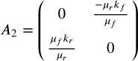

We can see that the resulting trace of <math xmlns="http://www.w3.org/1998/Math/MathML" display="block" data-is-equatio="1" data-latex="A_2"><msub><mi>A</mi><mn>2</mn></msub></math> is:



According to Cain, Reynolds (p. 67), the trace implies that the real part of the eigenvalues is 0, and the non-trivial fixed point is a center.

Solving for the eigenvalues, we get:



This leads to a phase portrait that looks like the following:

[Figure\_8](#utssy9xy42qs)

The phase portrait shows an oscillatory relationship between the rabbit and fox populations. This means that as the rabbit population decreases, the fox population increases. Additionally, as the rabbit population increases, the fox population decreases. This biologically makes sense as the rabbit population would decrease due to the foxes killing the rabbits for food, which would then lead to an increase in fox population. However, as the rabbit population decreases further, the foxes would lose their food supply, causing their population to start decreasing. Once the fox population decreases, the rabbits would be hunted less, which leads to an increase in their population. Aside from this, the oscillatory relationship between the rabbit and foxes will continue on infinitely for the same growth/decay.

# The Modified System

While we were able to analyze and understand the dynamics of our initial system, the system itself is not as accurate as it can be. By having exponential growth for the rabbit population, we are essentially allowing the population of the prey to increase without bound when the interaction between rabbits and foxes are nonexistent. In reality, however, this is not true. Hence, to portray a more accurate representation of the prey-predator system, we propose the following system where we replace the exponential growth of rabbit population with logistic growth.

<math xmlns="http://www.w3.org/1998/Math/MathML" display="block" data-is-equatio="1" data-latex="\frac{dR}{dt}=k_r R (1-\frac{R}{C_r})-\mu_r RF"><mfrac><mrow><mi>d</mi><mi>R</mi></mrow><mrow><mi>d</mi><mi>t</mi></mrow></mfrac><mo>=</mo><msub><mi>k</mi><mi>r</mi></msub><mi>R</mi><mo stretchy="false">(</mo><mn>1</mn><mo>−</mo><mfrac><mi>R</mi><msub><mi>C</mi><mi>r</mi></msub></mfrac><mo stretchy="false">)</mo><mo>−</mo><msub><mi>μ</mi><mi>r</mi></msub><mi>R</mi><mi>F</mi></math>



This new system is quite similar to our initial system where we have two equations, and <math xmlns="http://www.w3.org/1998/Math/MathML" display="block" data-is-equatio="1" data-latex="\frac{dF}{dt}"><mfrac><mrow><mi>d</mi><mi>F</mi></mrow><mrow><mi>d</mi><mi>t</mi></mrow></mfrac></math>, with a set of initial conditions for each population, <math xmlns="http://www.w3.org/1998/Math/MathML" display="block" data-is-equatio="1" data-latex="R(0)="><mi>R</mi><mo stretchy="false">(</mo><mn>0</mn><mo stretchy="false">)</mo><mo>=</mo></math><math xmlns="http://www.w3.org/1998/Math/MathML" display="block" data-is-equatio="1" data-latex="R_0"><msub><mi>R</mi><mn>0</mn></msub></math> and <math xmlns="http://www.w3.org/1998/Math/MathML" display="block" data-is-equatio="1" data-latex="F(0)="><mi>F</mi><mo stretchy="false">(</mo><mn>0</mn><mo stretchy="false">)</mo><mo>=</mo></math><math xmlns="http://www.w3.org/1998/Math/MathML" display="block" data-is-equatio="1" data-latex="F_0"><msub><mi>F</mi><mn>0</mn></msub></math>. The parameters <math xmlns="http://www.w3.org/1998/Math/MathML" display="block" data-is-equatio="1" data-latex="k_r"><msub><mi>k</mi><mi>r</mi></msub></math>, <math xmlns="http://www.w3.org/1998/Math/MathML" display="block" data-is-equatio="1" data-latex="\mu_f"><msub><mi>μ</mi><mi>f</mi></msub></math>, ,  carry over from the previous system with the same meaning. The only difference between the two systems is the addition of the parameter <math xmlns="http://www.w3.org/1998/Math/MathML" display="block" data-is-equatio="1" data-latex="C_r"><msub><mi>C</mi><mi>r</mi></msub></math>, which represents the carrying capacity of the rabbit population. This is the maximum number of rabbits that can exist.

## System under Different Scenarios

Similar to what we did with our initial system, we made different sets of parameters, each with their own restrictions on <math xmlns="http://www.w3.org/1998/Math/MathML" display="block" data-is-equatio="1" data-latex="k_r"><msub><mi>k</mi><mi>r</mi></msub></math>,<math xmlns="http://www.w3.org/1998/Math/MathML" display="block" data-is-equatio="1" data-latex="\mu_f"><msub><mi>μ</mi><mi>f</mi></msub></math>, , and  to help understand our current system better. Note that <math xmlns="http://www.w3.org/1998/Math/MathML" display="block" data-is-equatio="1" data-latex="C_r"><msub><mi>C</mi><mi>r</mi></msub></math> is set to a constant value of 10 for all scenarios.

With the help of Python plotting libraries, we modeled the same first two scenarios that we used for our initial system. We excluded the last scenario , <math xmlns="http://www.w3.org/1998/Math/MathML" display="block" data-is-equatio="1" data-latex="k_f&gt;0"><msub><mi>k</mi><mi>f</mi></msub><mo>&gt;</mo><mn>0</mn></math> as they would still be an unconventional and potentially unstable set of dynamics for the system.

### <math xmlns="http://www.w3.org/1998/Math/MathML" display="block" data-is-equatio="1" data-latex="k_r&gt;0"><msub><mi>k</mi><mi>r</mi></msub><mo>&gt;</mo><mn>0</mn></math> and <math xmlns="http://www.w3.org/1998/Math/MathML" display="block" data-is-equatio="1" data-latex="\mu_r=0"><msub><mi>μ</mi><mi>r</mi></msub><mo>=</mo><mn>0</mn></math>

This yields the general solution for the prey population as 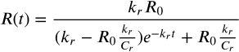. Below are examples of the change in prey population given different values of <math xmlns="http://www.w3.org/1998/Math/MathML" display="block" data-is-equatio="1" data-latex="R_0"><msub><mi>R</mi><mn>0</mn></msub></math> for a specific <math xmlns="http://www.w3.org/1998/Math/MathML" display="block" data-is-equatio="1" data-latex="k_r"><msub><mi>k</mi><mi>r</mi></msub></math>.

For <math xmlns="http://www.w3.org/1998/Math/MathML" display="block" data-is-equatio="1" data-latex="R_0=10"><msub><mi>R</mi><mn>0</mn></msub><mo>=</mo><mn>10</mn></math> and <math xmlns="http://www.w3.org/1998/Math/MathML" display="block" data-is-equatio="1" data-latex="k_r=2"><msub><mi>k</mi><mi>r</mi></msub><mo>=</mo><mn>2</mn></math>:

[Figure\_9](#7u1wdl8rautd)

For <math xmlns="http://www.w3.org/1998/Math/MathML" display="block" data-is-equatio="1" data-latex="R_0=1"><msub><mi>R</mi><mn>0</mn></msub><mo>=</mo><mn>1</mn></math> and <math xmlns="http://www.w3.org/1998/Math/MathML" display="block" data-is-equatio="1" data-latex="k_r=2"><msub><mi>k</mi><mi>r</mi></msub><mo>=</mo><mn>2</mn></math>:

[Figure\_10](#9lt0sq3f9qpg)

As we can see, under ideal conditions (i.e. no interaction with predators), the prey population will increase since there are no predators that would be using the prey as their food source. However, this growth would only continue until the carrying capacity is reached as the prey population cannot grow beyond that value.

### <math xmlns="http://www.w3.org/1998/Math/MathML" display="block" data-is-equatio="1" data-latex="k_f&gt;0"><msub><mi>k</mi><mi>f</mi></msub><mo>&gt;</mo><mn>0</mn></math> and mu sub f equals 0

This yields the same general solution for the predator population as our initial system, which is: <math xmlns="http://www.w3.org/1998/Math/MathML" display="block" data-is-equatio="1" data-latex="F(t) = F_0e^{-k_ft}"><mi>F</mi><mo stretchy="false">(</mo><mi>t</mi><mo stretchy="false">)</mo><mo>=</mo><msub><mi>F</mi><mn>0</mn></msub><msup><mi>e</mi><mrow data-mjx-texclass="ORD"><mo>−</mo><msub><mi>k</mi><mi>f</mi></msub><mi>t</mi></mrow></msup></math>. Below are examples of the change in prey population given different values of  for a specific <math xmlns="http://www.w3.org/1998/Math/MathML" display="block" data-is-equatio="1" data-latex="k_f"><msub><mi>k</mi><mi>f</mi></msub></math>.

For <math xmlns="http://www.w3.org/1998/Math/MathML" display="block" data-is-equatio="1" data-latex="F_0=1"><msub><mi>F</mi><mn>0</mn></msub><mo>=</mo><mn>1</mn></math>and <math xmlns="http://www.w3.org/1998/Math/MathML" display="block" data-is-equatio="1" data-latex="k_f=5"><msub><mi>k</mi><mi>f</mi></msub><mo>=</mo><mn>5</mn></math>:

[Figure\_11](#5s8u64rstnor)

For <math xmlns="http://www.w3.org/1998/Math/MathML" display="block" data-is-equatio="1" data-latex="F_0=10"><msub><mi>F</mi><mn>0</mn></msub><mo>=</mo><mn>10</mn></math> and <math xmlns="http://www.w3.org/1998/Math/MathML" display="block" data-is-equatio="1" data-latex="k_f=5"><msub><mi>k</mi><mi>f</mi></msub><mo>=</mo><mn>5</mn></math>:

[Figure\_12](#oc2f0pak34uv)

We can see that predators experience a natural mortality in the absence of prey consumption. Without their food source, the predators are not able to survive, causing their population to die off until there is no one remaining.

## Trivial and Non-Trivial Equilibrium Solutions and its Dynamics According to the Jacobian Matrix

<math xmlns="http://www.w3.org/1998/Math/MathML" display="block" data-is-equatio="1" data-latex="\frac{dR}{dt}=k_r R (1-\frac{R}{C_r})-\mu_r RF"><mfrac><mrow><mi>d</mi><mi>R</mi></mrow><mrow><mi>d</mi><mi>t</mi></mrow></mfrac><mo>=</mo><msub><mi>k</mi><mi>r</mi></msub><mi>R</mi><mo stretchy="false">(</mo><mn>1</mn><mo>−</mo><mfrac><mi>R</mi><msub><mi>C</mi><mi>r</mi></msub></mfrac><mo stretchy="false">)</mo><mo>−</mo><msub><mi>μ</mi><mi>r</mi></msub><mi>R</mi><mi>F</mi></math>



Trivial Solution: 

Non-Trivial Solution: 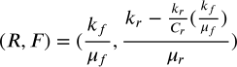

Since our general system is still a nonlinear system, we have to linearize the system by getting the Jacobian matrix in order to understand the dynamics (i.e. local stability) of the system close to the equilibrium.

The Jacobian matrix <math xmlns="http://www.w3.org/1998/Math/MathML" display="block" data-is-equatio="1" data-latex="A_3"><msub><mi>A</mi><mn>3</mn></msub></math> is shown below:

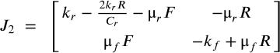

### Local Stability at the Trivial Fixed Point

The matrix  shown below is the Jacobian matrix <math xmlns="http://www.w3.org/1998/Math/MathML" display="block" data-is-equatio="1" data-latex="A_3"><msub><mi>A</mi><mn>3</mn></msub></math> evaluated at the Trivial Fixed Point:

<math xmlns="http://www.w3.org/1998/Math/MathML" display="block" data-is-equatio="1" data-latex="A_3=\begin{pmatrix}k_r&amp;0\\&#13;&#10;0&amp;-k_f\end{pmatrix}"><msub><mi>A</mi><mn>3</mn></msub><mo>=</mo><mrow data-mjx-texclass="INNER"><mo data-mjx-texclass="OPEN">(</mo><mtable columnspacing="1em" rowspacing="4pt"><mtr><mtd><msub><mi>k</mi><mi>r</mi></msub></mtd><mtd><mn>0</mn></mtd></mtr><mtr><mtd><mn>0</mn></mtd><mtd><mo>−</mo><msub><mi>k</mi><mi>f</mi></msub></mtd></mtr></mtable><mo data-mjx-texclass="CLOSE">)</mo></mrow></math>

From this, we can get the general solution of the linearized system <math xmlns="http://www.w3.org/1998/Math/MathML" display="block" data-is-equatio="1" data-latex="\mathbf{x}^{\prime}=A_3\mathbf{x}"><msup><mrow data-mjx-texclass="ORD"><mi mathvariant="bold">x</mi></mrow><mrow data-mjx-texclass="ORD"><mi data-mjx-alternate="1">′</mi></mrow></msup><mo>=</mo><msub><mi>A</mi><mn>3</mn></msub><mrow data-mjx-texclass="ORD"><mi mathvariant="bold">x</mi></mrow></math>:

<math xmlns="http://www.w3.org/1998/Math/MathML" display="block" data-is-equatio="1" data-latex="\begin{pmatrix}&#10;R(t) \\&#10;F(t)&#10;\end{pmatrix} = &#10;&#10;\begin{pmatrix}&#10;e^{k_rt} &amp; 0 \\&#10;0 &amp; e^{-k_ft}&#10;\end{pmatrix} \cdot &#10;&#10;\begin{pmatrix}&#10;R_0\\&#10;F_0&#10;\end{pmatrix} =&#10;\begin{pmatrix}&#10;R_0e^{k_rt}\\&#10;F_0e^{-k_ft}&#10;\end{pmatrix}"><mrow data-mjx-texclass="INNER"><mo data-mjx-texclass="OPEN">(</mo><mtable columnspacing="1em" rowspacing="4pt"><mtr><mtd><mi>R</mi><mo stretchy="false">(</mo><mi>t</mi><mo stretchy="false">)</mo></mtd></mtr><mtr><mtd><mi>F</mi><mo stretchy="false">(</mo><mi>t</mi><mo stretchy="false">)</mo></mtd></mtr></mtable><mo data-mjx-texclass="CLOSE">)</mo></mrow><mo>=</mo><mrow data-mjx-texclass="INNER"><mo data-mjx-texclass="OPEN">(</mo><mtable columnspacing="1em" rowspacing="4pt"><mtr><mtd><msup><mi>e</mi><mrow data-mjx-texclass="ORD"><msub><mi>k</mi><mi>r</mi></msub><mi>t</mi></mrow></msup></mtd><mtd><mn>0</mn></mtd></mtr><mtr><mtd><mn>0</mn></mtd><mtd><msup><mi>e</mi><mrow data-mjx-texclass="ORD"><mo>−</mo><msub><mi>k</mi><mi>f</mi></msub><mi>t</mi></mrow></msup></mtd></mtr></mtable><mo data-mjx-texclass="CLOSE">)</mo></mrow><mo>⋅</mo><mrow data-mjx-texclass="INNER"><mo data-mjx-texclass="OPEN">(</mo><mtable columnspacing="1em" rowspacing="4pt"><mtr><mtd><msub><mi>R</mi><mn>0</mn></msub></mtd></mtr><mtr><mtd><msub><mi>F</mi><mn>0</mn></msub></mtd></mtr></mtable><mo data-mjx-texclass="CLOSE">)</mo></mrow><mo>=</mo><mrow data-mjx-texclass="INNER"><mo data-mjx-texclass="OPEN">(</mo><mtable columnspacing="1em" rowspacing="4pt"><mtr><mtd><msub><mi>R</mi><mn>0</mn></msub><msup><mi>e</mi><mrow data-mjx-texclass="ORD"><msub><mi>k</mi><mi>r</mi></msub><mi>t</mi></mrow></msup></mtd></mtr><mtr><mtd><msub><mi>F</mi><mn>0</mn></msub><msup><mi>e</mi><mrow data-mjx-texclass="ORD"><mo>−</mo><msub><mi>k</mi><mi>f</mi></msub><mi>t</mi></mrow></msup></mtd></mtr></mtable><mo data-mjx-texclass="CLOSE">)</mo></mrow></math>

We can also see that the resulting determinant of <math xmlns="http://www.w3.org/1998/Math/MathML" display="block" data-is-equatio="1" data-latex="A_3"><msub><mi>A</mi><mn>3</mn></msub></math> is:

<math xmlns="http://www.w3.org/1998/Math/MathML" display="block" data-is-equatio="1" data-latex="\det(A_3)=\left(k_r\right)\left(-k_f\right)-\left(0\right)\left(0\right)=-k_rk_f"><mo data-mjx-texclass="OP" movablelimits="true">det</mo><mo stretchy="false">(</mo><msub><mi>A</mi><mn>3</mn></msub><mo stretchy="false">)</mo><mo>=</mo><mrow data-mjx-texclass="INNER"><mo data-mjx-texclass="OPEN">(</mo><msub><mi>k</mi><mi>r</mi></msub><mo data-mjx-texclass="CLOSE">)</mo></mrow><mrow data-mjx-texclass="INNER"><mo data-mjx-texclass="OPEN">(</mo><mo>−</mo><msub><mi>k</mi><mi>f</mi></msub><mo data-mjx-texclass="CLOSE">)</mo></mrow><mo>−</mo><mrow data-mjx-texclass="INNER"><mo data-mjx-texclass="OPEN">(</mo><mn>0</mn><mo data-mjx-texclass="CLOSE">)</mo></mrow><mrow data-mjx-texclass="INNER"><mo data-mjx-texclass="OPEN">(</mo><mn>0</mn><mo data-mjx-texclass="CLOSE">)</mo></mrow><mo>=</mo><mo>−</mo><msub><mi>k</mi><mi>r</mi></msub><msub><mi>k</mi><mi>f</mi></msub></math>

Similar to what we saw with the initial system, if we stick to conventional dynamics (, <math xmlns="http://www.w3.org/1998/Math/MathML" display="block" data-is-equatio="1" data-latex="k_f&gt;0"><msub><mi>k</mi><mi>f</mi></msub><mo>&gt;</mo><mn>0</mn></math>), then the determinant is negative, which means that the trivial fixed point (i.e. the origin) is a saddle.

This leads to a phase portrait that looks like the following:

[Figure\_13](#mkqie4ey94cm)

Similar to our initial system, the phase portrait above shows that the fox population would naturally decrease close to 0 and the rabbit population would keep increasing. However, this increase would be bounded according to the carrying capacity.

### Local Stability at the Non-Trivial Fixed Point

The matrix  shown below is the Jacobian matrix <math xmlns="http://www.w3.org/1998/Math/MathML" display="block" data-is-equatio="1" data-latex="A_3"><msub><mi>A</mi><mn>3</mn></msub></math> evaluated at the Non-Trivial Fixed Point:

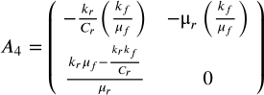

In order to analyze and understand the Jacobian matrix better, we will assign these values to the parameters: , <math xmlns="http://www.w3.org/1998/Math/MathML" display="block" data-is-equatio="1" data-latex="k_f = 5"><msub><mi>k</mi><mi>f</mi></msub><mo>=</mo><mn>5</mn></math>, , <math xmlns="http://www.w3.org/1998/Math/MathML" display="block" data-is-equatio="1" data-latex="\mu_f = 1"><msub><mi>μ</mi><mi>f</mi></msub><mo>=</mo><mn>1</mn></math>, <math xmlns="http://www.w3.org/1998/Math/MathML" display="block" data-is-equatio="1" data-latex="C_r = 10"><msub><mi>C</mi><mi>r</mi></msub><mo>=</mo><mn>10</mn></math>

With these values, we can see that the resulting trace of  is:

<math xmlns="http://www.w3.org/1998/Math/MathML" display="block" data-is-equatio="1" data-latex="tr\left(A_4\right)\ =\ -\frac{k_r}{C_r}\left(\frac{k_f}{\mu_f}\right)-0=-\frac{2}{10}\left(5\right)-0=-1-0=-1"><mi>t</mi><mi>r</mi><mrow data-mjx-texclass="INNER"><mo data-mjx-texclass="OPEN">(</mo><msub><mi>A</mi><mn>4</mn></msub><mo data-mjx-texclass="CLOSE">)</mo></mrow><mtext></mtext><mo>=</mo><mtext></mtext><mo>−</mo><mfrac><msub><mi>k</mi><mi>r</mi></msub><msub><mi>C</mi><mi>r</mi></msub></mfrac><mrow data-mjx-texclass="INNER"><mo data-mjx-texclass="OPEN">(</mo><mfrac><msub><mi>k</mi><mi>f</mi></msub><msub><mi>μ</mi><mi>f</mi></msub></mfrac><mo data-mjx-texclass="CLOSE">)</mo></mrow><mo>−</mo><mn>0</mn><mo>=</mo><mo>−</mo><mfrac><mn>2</mn><mn>10</mn></mfrac><mrow data-mjx-texclass="INNER"><mo data-mjx-texclass="OPEN">(</mo><mn>5</mn><mo data-mjx-texclass="CLOSE">)</mo></mrow><mo>−</mo><mn>0</mn><mo>=</mo><mo>−</mo><mn>1</mn><mo>−</mo><mn>0</mn><mo>=</mo><mo>−</mo><mn>1</mn></math>

According to Cain, Reynolds (p. 67), the trace implies that the real part of the eigenvalues is negative, and the non-trivial fixed point is a stable focus.

This leads to a phase portrait that looks like the following:

[Figure\_14](#cg0mntg8qpyb)

The phase portrait shows an oscillatory relationship between the rabbit and fox populations. This means that as the rabbit population decreases, the fox population increases. Additionally, as the rabbit population increases, the fox population decreases. However, as time goes on, both the rabbit and fox population oscillate towards the non-trivial fixed point, reaching the equilibrium.

## Discussion Topics

Using our modified system, we want to further understand the dynamics of our system under different conditions. Thus, we will explore the following discussion topics using the specific parameter values: , <math xmlns="http://www.w3.org/1998/Math/MathML" display="block" data-is-equatio="1" data-latex="k_f = 5"><msub><mi>k</mi><mi>f</mi></msub><mo>=</mo><mn>5</mn></math>, , <math xmlns="http://www.w3.org/1998/Math/MathML" display="block" data-is-equatio="1" data-latex="\mu_f = 1"><msub><mi>μ</mi><mi>f</mi></msub><mo>=</mo><mn>1</mn></math>, <math xmlns="http://www.w3.org/1998/Math/MathML" display="block" data-is-equatio="1" data-latex="C_r = 10"><msub><mi>C</mi><mi>r</mi></msub><mo>=</mo><mn>10</mn></math>.



1. Consider how the dynamics of this system would change if all parameter values other than <math xmlns="http://www.w3.org/1998/Math/MathML" display="block" data-is-equatio="1" data-latex="k_r"><msub><mi>k</mi><mi>r</mi></msub></math> were kept as you assigned them previously. Discuss how stability would change in this case.
2. Consider how the dynamics of this system would change if all parameter values other than <math xmlns="http://www.w3.org/1998/Math/MathML" display="block" data-is-equatio="1" data-latex="\mu_f"><msub><mi>μ</mi><mi>f</mi></msub></math> were kept as you assigned them previously. Discuss how stability would change in this case.

### Discussion #1

If <math xmlns="http://www.w3.org/1998/Math/MathML" display="block" data-is-equatio="1" data-latex="k_r"><msub><mi>k</mi><mi>r</mi></msub></math> is the only parameter kept arbitrary, we end up with the resulting Jacobian matrix  as:

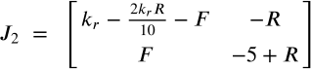

#### Trivial Fixed Point

For the trivial fixed point where <math xmlns="http://www.w3.org/1998/Math/MathML" display="block" data-is-equatio="1" data-latex="R=0"><mi>R</mi><mo>=</mo><mn>0</mn></math> and <math xmlns="http://www.w3.org/1998/Math/MathML" display="block" data-is-equatio="1" data-latex="F=0"><mi>F</mi><mo>=</mo><mn>0</mn></math>, we get:

<math xmlns="http://www.w3.org/1998/Math/MathML" display="block" data-is-equatio="1" data-latex="J_2\left(0,0\right)\ =\ \left[\begin{matrix}k_r&amp;0\\&#13;&#10;0&amp;-5\end{matrix}\right]"><msub><mi>J</mi><mn>2</mn></msub><mrow data-mjx-texclass="INNER"><mo data-mjx-texclass="OPEN">(</mo><mn>0</mn><mo>,</mo><mn>0</mn><mo data-mjx-texclass="CLOSE">)</mo></mrow><mtext></mtext><mo>=</mo><mtext></mtext><mrow data-mjx-texclass="INNER"><mo data-mjx-texclass="OPEN">[</mo><mtable columnspacing="1em" rowspacing="4pt"><mtr><mtd><msub><mi>k</mi><mi>r</mi></msub></mtd><mtd><mn>0</mn></mtd></mtr><mtr><mtd><mn>0</mn></mtd><mtd><mo>−</mo><mn>5</mn></mtd></mtr></mtable><mo data-mjx-texclass="CLOSE">]</mo></mrow></math>

This yields:

<math xmlns="http://www.w3.org/1998/Math/MathML" display="block" data-is-equatio="1" data-latex="tr\left(J_2\left(0,0\right)\right)=k_{r\ }-5"><mi>t</mi><mi>r</mi><mrow data-mjx-texclass="INNER"><mo data-mjx-texclass="OPEN">(</mo><msub><mi>J</mi><mn>2</mn></msub><mrow data-mjx-texclass="INNER"><mo data-mjx-texclass="OPEN">(</mo><mn>0</mn><mo>,</mo><mn>0</mn><mo data-mjx-texclass="CLOSE">)</mo></mrow><mo data-mjx-texclass="CLOSE">)</mo></mrow><mo>=</mo><msub><mi>k</mi><mrow data-mjx-texclass="ORD"><mi>r</mi><mtext></mtext></mrow></msub><mo>−</mo><mn>5</mn></math>

<math xmlns="http://www.w3.org/1998/Math/MathML" display="block" data-is-equatio="1" data-latex="\det\left(J_2\left(0,0\right)\right)=-5k_r\ "><mo data-mjx-texclass="OP" movablelimits="true">det</mo><mrow data-mjx-texclass="INNER"><mo data-mjx-texclass="OPEN">(</mo><msub><mi>J</mi><mn>2</mn></msub><mrow data-mjx-texclass="INNER"><mo data-mjx-texclass="OPEN">(</mo><mn>0</mn><mo>,</mo><mn>0</mn><mo data-mjx-texclass="CLOSE">)</mo></mrow><mo data-mjx-texclass="CLOSE">)</mo></mrow><mo>=</mo><mo>−</mo><mn>5</mn><msub><mi>k</mi><mi>r</mi></msub><mtext></mtext></math>

<math xmlns="http://www.w3.org/1998/Math/MathML" display="block" data-is-equatio="1" data-latex="tr\left(J_2\left(0,0\right)\right)^2-4\left(\det\left(J_2\left(0,0\right)\right)\right)=\left(k_r-5\right)^2-4\left(-5k_r\right)=k_r^2+10k_r+25=\left(k_r+5\right)^2"><mi>t</mi><mi>r</mi><msup><mrow data-mjx-texclass="INNER"><mo data-mjx-texclass="OPEN">(</mo><msub><mi>J</mi><mn>2</mn></msub><mrow data-mjx-texclass="INNER"><mo data-mjx-texclass="OPEN">(</mo><mn>0</mn><mo>,</mo><mn>0</mn><mo data-mjx-texclass="CLOSE">)</mo></mrow><mo data-mjx-texclass="CLOSE">)</mo></mrow><mn>2</mn></msup><mo>−</mo><mn>4</mn><mrow data-mjx-texclass="INNER"><mo data-mjx-texclass="OPEN">(</mo><mo data-mjx-texclass="OP" movablelimits="true">det</mo><mrow data-mjx-texclass="INNER"><mo data-mjx-texclass="OPEN">(</mo><msub><mi>J</mi><mn>2</mn></msub><mrow data-mjx-texclass="INNER"><mo data-mjx-texclass="OPEN">(</mo><mn>0</mn><mo>,</mo><mn>0</mn><mo data-mjx-texclass="CLOSE">)</mo></mrow><mo data-mjx-texclass="CLOSE">)</mo></mrow><mo data-mjx-texclass="CLOSE">)</mo></mrow><mo>=</mo><msup><mrow data-mjx-texclass="INNER"><mo data-mjx-texclass="OPEN">(</mo><msub><mi>k</mi><mi>r</mi></msub><mo>−</mo><mn>5</mn><mo data-mjx-texclass="CLOSE">)</mo></mrow><mn>2</mn></msup><mo>−</mo><mn>4</mn><mrow data-mjx-texclass="INNER"><mo data-mjx-texclass="OPEN">(</mo><mo>−</mo><mn>5</mn><msub><mi>k</mi><mi>r</mi></msub><mo data-mjx-texclass="CLOSE">)</mo></mrow><mo>=</mo><msubsup><mi>k</mi><mi>r</mi><mn>2</mn></msubsup><mo>+</mo><mn>10</mn><msub><mi>k</mi><mi>r</mi></msub><mo>+</mo><mn>25</mn><mo>=</mo><msup><mrow data-mjx-texclass="INNER"><mo data-mjx-texclass="OPEN">(</mo><msub><mi>k</mi><mi>r</mi></msub><mo>+</mo><mn>5</mn><mo data-mjx-texclass="CLOSE">)</mo></mrow><mn>2</mn></msup></math>

Through some analysis, we can derive these three cases:

1. When ,<math xmlns="http://www.w3.org/1998/Math/MathML" display="block" data-is-equatio="1" data-latex="\det\left(J_2\left(0,0\right)\right)&lt;0"><mo data-mjx-texclass="OP" movablelimits="true">det</mo><mrow data-mjx-texclass="INNER"><mo data-mjx-texclass="OPEN">(</mo><msub><mi>J</mi><mn>2</mn></msub><mrow data-mjx-texclass="INNER"><mo data-mjx-texclass="OPEN">(</mo><mn>0</mn><mo>,</mo><mn>0</mn><mo data-mjx-texclass="CLOSE">)</mo></mrow><mo data-mjx-texclass="CLOSE">)</mo></mrow><mo>&lt;</mo><mn>0</mn></math>. This means that trivial fixed point (i.e. origin) is a saddle
   1. [Figure\_15](#pjqcm1i32q6s)
   2. The phase portrait above shows that with , the rabbit population would keep increasing as the fox population would decrease toward 0.
2. When , <math xmlns="http://www.w3.org/1998/Math/MathML" display="block" data-is-equatio="1" data-latex="\det\left(J_2\left(0,0\right)\right)&lt;0"><mo data-mjx-texclass="OP" movablelimits="true">det</mo><mrow data-mjx-texclass="INNER"><mo data-mjx-texclass="OPEN">(</mo><msub><mi>J</mi><mn>2</mn></msub><mrow data-mjx-texclass="INNER"><mo data-mjx-texclass="OPEN">(</mo><mn>0</mn><mo>,</mo><mn>0</mn><mo data-mjx-texclass="CLOSE">)</mo></mrow><mo data-mjx-texclass="CLOSE">)</mo></mrow><mo>&lt;</mo><mn>0</mn></math>, <math xmlns="http://www.w3.org/1998/Math/MathML" display="block" data-is-equatio="1" data-latex="tr\left(J_2\left(0,0\right)\right)^2-4\left(\det\left(J_2\left(0,0\right)\right)\right)&gt;0"><mi>t</mi><mi>r</mi><msup><mrow data-mjx-texclass="INNER"><mo data-mjx-texclass="OPEN">(</mo><msub><mi>J</mi><mn>2</mn></msub><mrow data-mjx-texclass="INNER"><mo data-mjx-texclass="OPEN">(</mo><mn>0</mn><mo>,</mo><mn>0</mn><mo data-mjx-texclass="CLOSE">)</mo></mrow><mo data-mjx-texclass="CLOSE">)</mo></mrow><mn>2</mn></msup><mo>−</mo><mn>4</mn><mrow data-mjx-texclass="INNER"><mo data-mjx-texclass="OPEN">(</mo><mo data-mjx-texclass="OP" movablelimits="true">det</mo><mrow data-mjx-texclass="INNER"><mo data-mjx-texclass="OPEN">(</mo><msub><mi>J</mi><mn>2</mn></msub><mrow data-mjx-texclass="INNER"><mo data-mjx-texclass="OPEN">(</mo><mn>0</mn><mo>,</mo><mn>0</mn><mo data-mjx-texclass="CLOSE">)</mo></mrow><mo data-mjx-texclass="CLOSE">)</mo></mrow><mo data-mjx-texclass="CLOSE">)</mo></mrow><mo>&gt;</mo><mn>0</mn></math> and <math xmlns="http://www.w3.org/1998/Math/MathML" display="block" data-is-equatio="1" data-latex="tr\left(J_2\left(0,0\right)\right)&lt;0"><mi>t</mi><mi>r</mi><mrow data-mjx-texclass="INNER"><mo data-mjx-texclass="OPEN">(</mo><msub><mi>J</mi><mn>2</mn></msub><mrow data-mjx-texclass="INNER"><mo data-mjx-texclass="OPEN">(</mo><mn>0</mn><mo>,</mo><mn>0</mn><mo data-mjx-texclass="CLOSE">)</mo></mrow><mo data-mjx-texclass="CLOSE">)</mo></mrow><mo>&lt;</mo><mn>0</mn></math> for all values of <math xmlns="http://www.w3.org/1998/Math/MathML" display="block" data-is-equatio="1" data-latex="k_r"><msub><mi>k</mi><mi>r</mi></msub></math>, which means that the eigenvalues are real and negative and the origin is stable
   1. [Figure\_16](#833bbqr0gr3r)
   2. The phase portrait above shows that with , both the fox population and rabbit population decrease toward 0, meaning that both species die out. This makes sense since the rabbits would naturally die due to . This would lead to the fox population to die as well since they are losing their food supply. However, this case does not make sense biologically as the rabbit population should not die off naturally.
3. When <math xmlns="http://www.w3.org/1998/Math/MathML" display="block" data-is-equatio="1" data-latex="k_r=0"><msub><mi>k</mi><mi>r</mi></msub><mo>=</mo><mn>0</mn></math>, this means that the natural growth rate of the rabbit population is 0, which contradicts the definition of the “growth model”. Hence, we will ignore this case.

#### Non-Trivial Fixed Point

For the non-trivial fixed point where and<math xmlns="http://www.w3.org/1998/Math/MathML" display="block" data-is-equatio="1" data-latex="F=F\text{*}"><mi>F</mi><mo>=</mo><mi>F</mi><mtext>*</mtext></math>  
 Since

, <math xmlns="http://www.w3.org/1998/Math/MathML" display="block" data-is-equatio="1" data-latex="k_f = 5"><msub><mi>k</mi><mi>f</mi></msub><mo>=</mo><mn>5</mn></math>, , <math xmlns="http://www.w3.org/1998/Math/MathML" display="block" data-is-equatio="1" data-latex="\mu_f = 1"><msub><mi>μ</mi><mi>f</mi></msub><mo>=</mo><mn>1</mn></math>, <math xmlns="http://www.w3.org/1998/Math/MathML" display="block" data-is-equatio="1" data-latex="C_r = 10"><msub><mi>C</mi><mi>r</mi></msub><mo>=</mo><mn>10</mn></math>

We get

<math xmlns="http://www.w3.org/1998/Math/MathML" display="block" data-is-equatio="1" data-latex="R\text{*}=\frac{k_f}{μ_f}=5"><mi>R</mi><mtext>*</mtext><mo>=</mo><mfrac><msub><mi>k</mi><mi>f</mi></msub><msub><mi>μ</mi><mi>f</mi></msub></mfrac><mo>=</mo><mn>5</mn></math>, 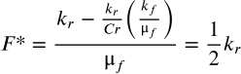

Since



We will get

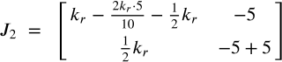

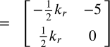

This yields:

<math xmlns="http://www.w3.org/1998/Math/MathML" display="block" data-is-equatio="1" data-latex="tr\left(J_2\left(R\text{*},F\text{*}\right)\right)=-\frac{1}{2}k_r"><mi>t</mi><mi>r</mi><mrow data-mjx-texclass="INNER"><mo data-mjx-texclass="OPEN">(</mo><msub><mi>J</mi><mn>2</mn></msub><mrow data-mjx-texclass="INNER"><mo data-mjx-texclass="OPEN">(</mo><mi>R</mi><mtext>*</mtext><mo>,</mo><mi>F</mi><mtext>*</mtext><mo data-mjx-texclass="CLOSE">)</mo></mrow><mo data-mjx-texclass="CLOSE">)</mo></mrow><mo>=</mo><mo>−</mo><mfrac><mn>1</mn><mn>2</mn></mfrac><msub><mi>k</mi><mi>r</mi></msub></math>

<math xmlns="http://www.w3.org/1998/Math/MathML" display="block" data-is-equatio="1" data-latex="\det\left(J_2\left(R\text{*},F\text{*}\right)\right)=\frac{5}{2}k_r"><mo data-mjx-texclass="OP" movablelimits="true">det</mo><mrow data-mjx-texclass="INNER"><mo data-mjx-texclass="OPEN">(</mo><msub><mi>J</mi><mn>2</mn></msub><mrow data-mjx-texclass="INNER"><mo data-mjx-texclass="OPEN">(</mo><mi>R</mi><mtext>*</mtext><mo>,</mo><mi>F</mi><mtext>*</mtext><mo data-mjx-texclass="CLOSE">)</mo></mrow><mo data-mjx-texclass="CLOSE">)</mo></mrow><mo>=</mo><mfrac><mn>5</mn><mn>2</mn></mfrac><msub><mi>k</mi><mi>r</mi></msub></math>



Through some analysis, we can derive these three cases:

1. When <math xmlns="http://www.w3.org/1998/Math/MathML" display="block" data-is-equatio="1" data-latex="k_r&lt;0"><msub><mi>k</mi><mi>r</mi></msub><mo>&lt;</mo><mn>0</mn></math>, <math xmlns="http://www.w3.org/1998/Math/MathML" display="block" data-is-equatio="1" data-latex="\det\left(J\left(R\text{*},F\text{*}\right)\right)&lt;0"><mo data-mjx-texclass="OP" movablelimits="true">det</mo><mrow data-mjx-texclass="INNER"><mo data-mjx-texclass="OPEN">(</mo><mi>J</mi><mrow data-mjx-texclass="INNER"><mo data-mjx-texclass="OPEN">(</mo><mi>R</mi><mtext>*</mtext><mo>,</mo><mi>F</mi><mtext>*</mtext><mo data-mjx-texclass="CLOSE">)</mo></mrow><mo data-mjx-texclass="CLOSE">)</mo></mrow><mo>&lt;</mo><mn>0</mn></math>, which means that the non-trivial fixed point is a saddle.
   1. [Figure\_17](#8xaack6xq9zr)
   2. If <math xmlns="http://www.w3.org/1998/Math/MathML" display="block" data-is-equatio="1" data-latex="k_r&lt;0"><msub><mi>k</mi><mi>r</mi></msub><mo>&lt;</mo><mn>0</mn></math>, this does not make sense biologically as this would mean that the rabbit population naturally decreases. Hence, we will ignore this situation.
2. When <math xmlns="http://www.w3.org/1998/Math/MathML" display="block" data-is-equatio="1" data-latex="0 &lt; k_r &lt; 40"><mn>0</mn><mo>&lt;</mo><msub><mi>k</mi><mi>r</mi></msub><mo>&lt;</mo><mn>40</mn></math>, <math xmlns="http://www.w3.org/1998/Math/MathML" display="block" data-is-equatio="1" data-latex=" \det\left(J\left(R\text{*},F\text{*}\right)\right)&gt;0"><mo data-mjx-texclass="OP" movablelimits="true">det</mo><mrow data-mjx-texclass="INNER"><mo data-mjx-texclass="OPEN">(</mo><mi>J</mi><mrow data-mjx-texclass="INNER"><mo data-mjx-texclass="OPEN">(</mo><mi>R</mi><mtext>*</mtext><mo>,</mo><mi>F</mi><mtext>*</mtext><mo data-mjx-texclass="CLOSE">)</mo></mrow><mo data-mjx-texclass="CLOSE">)</mo></mrow><mo>&gt;</mo><mn>0</mn></math>, <math xmlns="http://www.w3.org/1998/Math/MathML" display="block" data-is-equatio="1" data-latex="tr\left(J_2\left(R\text{*},F\text{*}\right)\right)&lt;0"><mi>t</mi><mi>r</mi><mrow data-mjx-texclass="INNER"><mo data-mjx-texclass="OPEN">(</mo><msub><mi>J</mi><mn>2</mn></msub><mrow data-mjx-texclass="INNER"><mo data-mjx-texclass="OPEN">(</mo><mi>R</mi><mtext>*</mtext><mo>,</mo><mi>F</mi><mtext>*</mtext><mo data-mjx-texclass="CLOSE">)</mo></mrow><mo data-mjx-texclass="CLOSE">)</mo></mrow><mo>&lt;</mo><mn>0</mn></math>, and <math xmlns="http://www.w3.org/1998/Math/MathML" display="block" data-is-equatio="1" data-latex="tr\left(J_2\left(R\text{*},F\text{*}\right)\right)^2-4\left(\det\left(J_2\left(R\text{*},F\text{*}\right)\right)\right)&lt;0"><mi>t</mi><mi>r</mi><msup><mrow data-mjx-texclass="INNER"><mo data-mjx-texclass="OPEN">(</mo><msub><mi>J</mi><mn>2</mn></msub><mrow data-mjx-texclass="INNER"><mo data-mjx-texclass="OPEN">(</mo><mi>R</mi><mtext>*</mtext><mo>,</mo><mi>F</mi><mtext>*</mtext><mo data-mjx-texclass="CLOSE">)</mo></mrow><mo data-mjx-texclass="CLOSE">)</mo></mrow><mn>2</mn></msup><mo>−</mo><mn>4</mn><mrow data-mjx-texclass="INNER"><mo data-mjx-texclass="OPEN">(</mo><mo data-mjx-texclass="OP" movablelimits="true">det</mo><mrow data-mjx-texclass="INNER"><mo data-mjx-texclass="OPEN">(</mo><msub><mi>J</mi><mn>2</mn></msub><mrow data-mjx-texclass="INNER"><mo data-mjx-texclass="OPEN">(</mo><mi>R</mi><mtext>*</mtext><mo>,</mo><mi>F</mi><mtext>*</mtext><mo data-mjx-texclass="CLOSE">)</mo></mrow><mo data-mjx-texclass="CLOSE">)</mo></mrow><mo data-mjx-texclass="CLOSE">)</mo></mrow><mo>&lt;</mo><mn>0</mn></math>. This means that the non-trivial fixed point is a stable focus.
   1. [Figure\_18](#ukprblcw51gw)
   2. In this situation, the fox and rabbits have an oscillatory relationship where as one increases, the other decreases. However, as this oscillation continues to occur, both populations slowly decrease toward the non-trivial fixed point.
3. When <math xmlns="http://www.w3.org/1998/Math/MathML" display="block" data-is-equatio="1" data-latex="k_r\ge40,\ \det\left(J\left(R\text{*},F\text{*}\right)\right)&gt;0,\ tr\left(J\left(R\text{*},F\text{*}\right)\right)&lt;0"><msub><mi>k</mi><mi>r</mi></msub><mo>≥</mo><mn>40</mn><mo>,</mo><mtext></mtext><mo data-mjx-texclass="OP" movablelimits="true">det</mo><mrow data-mjx-texclass="INNER"><mo data-mjx-texclass="OPEN">(</mo><mi>J</mi><mrow data-mjx-texclass="INNER"><mo data-mjx-texclass="OPEN">(</mo><mi>R</mi><mtext>*</mtext><mo>,</mo><mi>F</mi><mtext>*</mtext><mo data-mjx-texclass="CLOSE">)</mo></mrow><mo data-mjx-texclass="CLOSE">)</mo></mrow><mo>&gt;</mo><mn>0</mn><mo>,</mo><mtext></mtext><mi>t</mi><mi>r</mi><mrow data-mjx-texclass="INNER"><mo data-mjx-texclass="OPEN">(</mo><mi>J</mi><mrow data-mjx-texclass="INNER"><mo data-mjx-texclass="OPEN">(</mo><mi>R</mi><mtext>*</mtext><mo>,</mo><mi>F</mi><mtext>*</mtext><mo data-mjx-texclass="CLOSE">)</mo></mrow><mo data-mjx-texclass="CLOSE">)</mo></mrow><mo>&lt;</mo><mn>0</mn></math>, and <math xmlns="http://www.w3.org/1998/Math/MathML" display="block" data-is-equatio="1" data-latex="tr\left(J_2\left(R\text{*},F\text{*}\right)\right)^2-4\left(\det\left(J_2\left(R\text{*},F\text{*}\right)\right)\right)\ge0"><mi>t</mi><mi>r</mi><msup><mrow data-mjx-texclass="INNER"><mo data-mjx-texclass="OPEN">(</mo><msub><mi>J</mi><mn>2</mn></msub><mrow data-mjx-texclass="INNER"><mo data-mjx-texclass="OPEN">(</mo><mi>R</mi><mtext>*</mtext><mo>,</mo><mi>F</mi><mtext>*</mtext><mo data-mjx-texclass="CLOSE">)</mo></mrow><mo data-mjx-texclass="CLOSE">)</mo></mrow><mn>2</mn></msup><mo>−</mo><mn>4</mn><mrow data-mjx-texclass="INNER"><mo data-mjx-texclass="OPEN">(</mo><mo data-mjx-texclass="OP" movablelimits="true">det</mo><mrow data-mjx-texclass="INNER"><mo data-mjx-texclass="OPEN">(</mo><msub><mi>J</mi><mn>2</mn></msub><mrow data-mjx-texclass="INNER"><mo data-mjx-texclass="OPEN">(</mo><mi>R</mi><mtext>*</mtext><mo>,</mo><mi>F</mi><mtext>*</mtext><mo data-mjx-texclass="CLOSE">)</mo></mrow><mo data-mjx-texclass="CLOSE">)</mo></mrow><mo data-mjx-texclass="CLOSE">)</mo></mrow><mo>≥</mo><mn>0</mn></math>. This means that the non-trivial fixed point is a stable node.
   1. [Figure\_19](#aq05fsa2bniy)
   2. In this scenario, the rabbit's growth rate is too high such that the population reaches its carrying capacity at a much quicker rate. This, in turn, forces the growth of the rabbit population to become stagnant as it cannot grow any further. Additionally, given the quick increase in the rabbit population, the foxes would have more rabbits to hunt, causing the rabbit population to decrease and the fox population to increase.

### Discussion #2

If <math xmlns="http://www.w3.org/1998/Math/MathML" display="block" data-is-equatio="1" data-latex="\mu_f"><msub><mi>μ</mi><mi>f</mi></msub></math> is the only parameter kept arbitrary, we end up with the resulting Jacobian matrix  as:

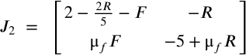

#### Trivial Fixed Point

For the trivial fixed point where <math xmlns="http://www.w3.org/1998/Math/MathML" display="block" data-is-equatio="1" data-latex="R=0"><mi>R</mi><mo>=</mo><mn>0</mn></math> and <math xmlns="http://www.w3.org/1998/Math/MathML" display="block" data-is-equatio="1" data-latex="F=0"><mi>F</mi><mo>=</mo><mn>0</mn></math>, we get:

<math xmlns="http://www.w3.org/1998/Math/MathML" display="block" data-is-equatio="1" data-latex="J_2\left(0,0\right)\ =\ \left[\begin{matrix}2&amp;0\\&#13;&#10;0&amp;-5\end{matrix}\right]"><msub><mi>J</mi><mn>2</mn></msub><mrow data-mjx-texclass="INNER"><mo data-mjx-texclass="OPEN">(</mo><mn>0</mn><mo>,</mo><mn>0</mn><mo data-mjx-texclass="CLOSE">)</mo></mrow><mtext></mtext><mo>=</mo><mtext></mtext><mrow data-mjx-texclass="INNER"><mo data-mjx-texclass="OPEN">[</mo><mtable columnspacing="1em" rowspacing="4pt"><mtr><mtd><mn>2</mn></mtd><mtd><mn>0</mn></mtd></mtr><mtr><mtd><mn>0</mn></mtd><mtd><mo>−</mo><mn>5</mn></mtd></mtr></mtable><mo data-mjx-texclass="CLOSE">]</mo></mrow></math>

This means that the eigenvalues for <math xmlns="http://www.w3.org/1998/Math/MathML" display="block" data-is-equatio="1" data-latex="J_2\left(0,0\right)"><msub><mi>J</mi><mn>2</mn></msub><mrow data-mjx-texclass="INNER"><mo data-mjx-texclass="OPEN">(</mo><mn>0</mn><mo>,</mo><mn>0</mn><mo data-mjx-texclass="CLOSE">)</mo></mrow></math> will always be 2 and -5 regardless of the value of <math xmlns="http://www.w3.org/1998/Math/MathML" display="block" data-is-equatio="1" data-latex="\mu_f"><msub><mi>μ</mi><mi>f</mi></msub></math> based on our parameters. Hence, this means that the origin is always a saddle.

[Figure\_20](#tip4q19bw47a)

Similar to other situations we have encountered, the phase portrait above shows that without the interaction between foxes and rabbits, the fox population would naturally decrease close to 0 since they do not have a food source, and the rabbit population would keep increasing due to the fact they are not getting hunted.

#### Non-Trivial Fixed Point

For the non-trivial fixed point where and<math xmlns="http://www.w3.org/1998/Math/MathML" display="block" data-is-equatio="1" data-latex="F=F\text{*}"><mi>F</mi><mo>=</mo><mi>F</mi><mtext>*</mtext></math>

<math xmlns="http://www.w3.org/1998/Math/MathML" display="block" data-is-equatio="1" data-latex="R\text{*}=\frac{k_f}{μ_f}=\frac{5}{μ_f}"><mi>R</mi><mtext>*</mtext><mo>=</mo><mfrac><msub><mi>k</mi><mi>f</mi></msub><msub><mi>μ</mi><mi>f</mi></msub></mfrac><mo>=</mo><mfrac><mn>5</mn><msub><mi>μ</mi><mi>f</mi></msub></mfrac></math>, 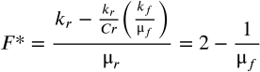

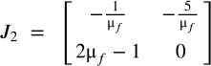

This yields:







Through some analysis, we can derive these five cases:

1. When <math xmlns="http://www.w3.org/1998/Math/MathML" display="block" data-is-equatio="1" data-latex="μ_f&lt;-0.046"><msub><mi>μ</mi><mi>f</mi></msub><mo>&lt;</mo><mo>−</mo><mn>0.046</mn></math>, <math xmlns="http://www.w3.org/1998/Math/MathML" display="block" data-is-equatio="1" data-latex="tr\left(J_2\left(R\text{*},F\text{*}\right)\right)&gt;0,\ \det\left(J_2\left(R\text{*},F\text{*}\right)\right)&gt;0,\ tr\left(J_2\left(R\text{*},F\text{*}\right)\right)^2-4\det\left(J_2\left(R\text{*},F\text{*}\right)\right)&lt;0"><mi>t</mi><mi>r</mi><mrow data-mjx-texclass="INNER"><mo data-mjx-texclass="OPEN">(</mo><msub><mi>J</mi><mn>2</mn></msub><mrow data-mjx-texclass="INNER"><mo data-mjx-texclass="OPEN">(</mo><mi>R</mi><mtext>*</mtext><mo>,</mo><mi>F</mi><mtext>*</mtext><mo data-mjx-texclass="CLOSE">)</mo></mrow><mo data-mjx-texclass="CLOSE">)</mo></mrow><mo>&gt;</mo><mn>0</mn><mo>,</mo><mtext></mtext><mo data-mjx-texclass="OP" movablelimits="true">det</mo><mrow data-mjx-texclass="INNER"><mo data-mjx-texclass="OPEN">(</mo><msub><mi>J</mi><mn>2</mn></msub><mrow data-mjx-texclass="INNER"><mo data-mjx-texclass="OPEN">(</mo><mi>R</mi><mtext>*</mtext><mo>,</mo><mi>F</mi><mtext>*</mtext><mo data-mjx-texclass="CLOSE">)</mo></mrow><mo data-mjx-texclass="CLOSE">)</mo></mrow><mo>&gt;</mo><mn>0</mn><mo>,</mo><mtext></mtext><mi>t</mi><mi>r</mi><msup><mrow data-mjx-texclass="INNER"><mo data-mjx-texclass="OPEN">(</mo><msub><mi>J</mi><mn>2</mn></msub><mrow data-mjx-texclass="INNER"><mo data-mjx-texclass="OPEN">(</mo><mi>R</mi><mtext>*</mtext><mo>,</mo><mi>F</mi><mtext>*</mtext><mo data-mjx-texclass="CLOSE">)</mo></mrow><mo data-mjx-texclass="CLOSE">)</mo></mrow><mn>2</mn></msup><mo>−</mo><mn>4</mn><mo data-mjx-texclass="OP" movablelimits="true">det</mo><mrow data-mjx-texclass="INNER"><mo data-mjx-texclass="OPEN">(</mo><msub><mi>J</mi><mn>2</mn></msub><mrow data-mjx-texclass="INNER"><mo data-mjx-texclass="OPEN">(</mo><mi>R</mi><mtext>*</mtext><mo>,</mo><mi>F</mi><mtext>*</mtext><mo data-mjx-texclass="CLOSE">)</mo></mrow><mo data-mjx-texclass="CLOSE">)</mo></mrow><mo>&lt;</mo><mn>0</mn></math>. The non-trivial fixed point is an unstable focus.
   1. [Figure\_21](#ilapllocuke4)
   2. If <math xmlns="http://www.w3.org/1998/Math/MathML" display="block" data-is-equatio="1" data-latex="μ_f&lt;0"><msub><mi>μ</mi><mi>f</mi></msub><mo>&lt;</mo><mn>0</mn></math>, this means that the interaction between rabbits and foxes would lead to a decrease in the fox population, which does not make sense biologically. Thus, we will ignore this situation.
2. When , <math xmlns="http://www.w3.org/1998/Math/MathML" display="block" data-is-equatio="1" data-latex="tr\left(J_2\left(R\text{*},F\text{*}\right)\right)&gt;0,\ \det\left(J_2\left(R\text{*},F\text{*}\right)\right)&gt;0,\ tr\left(J_2\left(R\text{*},F\text{*}\right)\right)^2-4\det\left(J_2\left(R\text{*},F\text{*}\right)\right)\ge0"><mi>t</mi><mi>r</mi><mrow data-mjx-texclass="INNER"><mo data-mjx-texclass="OPEN">(</mo><msub><mi>J</mi><mn>2</mn></msub><mrow data-mjx-texclass="INNER"><mo data-mjx-texclass="OPEN">(</mo><mi>R</mi><mtext>*</mtext><mo>,</mo><mi>F</mi><mtext>*</mtext><mo data-mjx-texclass="CLOSE">)</mo></mrow><mo data-mjx-texclass="CLOSE">)</mo></mrow><mo>&gt;</mo><mn>0</mn><mo>,</mo><mtext></mtext><mo data-mjx-texclass="OP" movablelimits="true">det</mo><mrow data-mjx-texclass="INNER"><mo data-mjx-texclass="OPEN">(</mo><msub><mi>J</mi><mn>2</mn></msub><mrow data-mjx-texclass="INNER"><mo data-mjx-texclass="OPEN">(</mo><mi>R</mi><mtext>*</mtext><mo>,</mo><mi>F</mi><mtext>*</mtext><mo data-mjx-texclass="CLOSE">)</mo></mrow><mo data-mjx-texclass="CLOSE">)</mo></mrow><mo>&gt;</mo><mn>0</mn><mo>,</mo><mtext></mtext><mi>t</mi><mi>r</mi><msup><mrow data-mjx-texclass="INNER"><mo data-mjx-texclass="OPEN">(</mo><msub><mi>J</mi><mn>2</mn></msub><mrow data-mjx-texclass="INNER"><mo data-mjx-texclass="OPEN">(</mo><mi>R</mi><mtext>*</mtext><mo>,</mo><mi>F</mi><mtext>*</mtext><mo data-mjx-texclass="CLOSE">)</mo></mrow><mo data-mjx-texclass="CLOSE">)</mo></mrow><mn>2</mn></msup><mo>−</mo><mn>4</mn><mo data-mjx-texclass="OP" movablelimits="true">det</mo><mrow data-mjx-texclass="INNER"><mo data-mjx-texclass="OPEN">(</mo><msub><mi>J</mi><mn>2</mn></msub><mrow data-mjx-texclass="INNER"><mo data-mjx-texclass="OPEN">(</mo><mi>R</mi><mtext>*</mtext><mo>,</mo><mi>F</mi><mtext>*</mtext><mo data-mjx-texclass="CLOSE">)</mo></mrow><mo data-mjx-texclass="CLOSE">)</mo></mrow><mo>≥</mo><mn>0</mn></math>The non-trivial fixed point is an unstable node.
   1. [Figure\_22](#s30ovjirlb98)
   2. Similar to the previous case, we will ignore it since <math xmlns="http://www.w3.org/1998/Math/MathML" display="block" data-is-equatio="1" data-latex="μ_f&lt;0"><msub><mi>μ</mi><mi>f</mi></msub><mo>&lt;</mo><mn>0</mn></math> does not make sense biologically.
3. When , <math xmlns="http://www.w3.org/1998/Math/MathML" display="block" data-is-equatio="1" data-latex="\det\left(J_2\left(R\text{*},F\text{*}\right)\right)&lt;0"><mo data-mjx-texclass="OP" movablelimits="true">det</mo><mrow data-mjx-texclass="INNER"><mo data-mjx-texclass="OPEN">(</mo><msub><mi>J</mi><mn>2</mn></msub><mrow data-mjx-texclass="INNER"><mo data-mjx-texclass="OPEN">(</mo><mi>R</mi><mtext>*</mtext><mo>,</mo><mi>F</mi><mtext>*</mtext><mo data-mjx-texclass="CLOSE">)</mo></mrow><mo data-mjx-texclass="CLOSE">)</mo></mrow><mo>&lt;</mo><mn>0</mn></math> . The non-trivial fixed point is a saddle.
   1. [Figure\_23](#ax1luyer7krn)
   2. The non-trivial fixed point acts as a saddle point in the system. A decline in the rabbit population leads to a subsequent decrease in the fox population. However, this dynamic does not lead the system back to the equilibrium represented by the fixed point; instead, the populations diverge from it.
4. When <math xmlns="http://www.w3.org/1998/Math/MathML" display="block" data-is-equatio="1" data-latex="0.5&lt;μ_f\le0.546"><mn>0.5</mn><mo>&lt;</mo><msub><mi>μ</mi><mi>f</mi></msub><mo>≤</mo><mn>0.546</mn></math>, <math xmlns="http://www.w3.org/1998/Math/MathML" display="block" data-is-equatio="1" data-latex="tr\left(J_2\left(R\text{*},F\text{*}\right)\right)&lt;0,\ \det\left(J_2\left(R\text{*},F\text{*}\right)\right)&gt;0,\ tr\left(J_2\left(R\text{*},F\text{*}\right)\right)^2-4\det\left(J_2\left(R\text{*},F\text{*}\right)\right)\ge0"><mi>t</mi><mi>r</mi><mrow data-mjx-texclass="INNER"><mo data-mjx-texclass="OPEN">(</mo><msub><mi>J</mi><mn>2</mn></msub><mrow data-mjx-texclass="INNER"><mo data-mjx-texclass="OPEN">(</mo><mi>R</mi><mtext>*</mtext><mo>,</mo><mi>F</mi><mtext>*</mtext><mo data-mjx-texclass="CLOSE">)</mo></mrow><mo data-mjx-texclass="CLOSE">)</mo></mrow><mo>&lt;</mo><mn>0</mn><mo>,</mo><mtext></mtext><mo data-mjx-texclass="OP" movablelimits="true">det</mo><mrow data-mjx-texclass="INNER"><mo data-mjx-texclass="OPEN">(</mo><msub><mi>J</mi><mn>2</mn></msub><mrow data-mjx-texclass="INNER"><mo data-mjx-texclass="OPEN">(</mo><mi>R</mi><mtext>*</mtext><mo>,</mo><mi>F</mi><mtext>*</mtext><mo data-mjx-texclass="CLOSE">)</mo></mrow><mo data-mjx-texclass="CLOSE">)</mo></mrow><mo>&gt;</mo><mn>0</mn><mo>,</mo><mtext></mtext><mi>t</mi><mi>r</mi><msup><mrow data-mjx-texclass="INNER"><mo data-mjx-texclass="OPEN">(</mo><msub><mi>J</mi><mn>2</mn></msub><mrow data-mjx-texclass="INNER"><mo data-mjx-texclass="OPEN">(</mo><mi>R</mi><mtext>*</mtext><mo>,</mo><mi>F</mi><mtext>*</mtext><mo data-mjx-texclass="CLOSE">)</mo></mrow><mo data-mjx-texclass="CLOSE">)</mo></mrow><mn>2</mn></msup><mo>−</mo><mn>4</mn><mo data-mjx-texclass="OP" movablelimits="true">det</mo><mrow data-mjx-texclass="INNER"><mo data-mjx-texclass="OPEN">(</mo><msub><mi>J</mi><mn>2</mn></msub><mrow data-mjx-texclass="INNER"><mo data-mjx-texclass="OPEN">(</mo><mi>R</mi><mtext>*</mtext><mo>,</mo><mi>F</mi><mtext>*</mtext><mo data-mjx-texclass="CLOSE">)</mo></mrow><mo data-mjx-texclass="CLOSE">)</mo></mrow><mo>≥</mo><mn>0</mn></math>The non-trivial fixed point is a stable node.
   1. [Figure\_24](#24pky3kupgug)
   2. The non-trivial fixed point is therefore a stable node. A decrease in the rabbit population results in a decrease in the fox population. In the long term, both fox and rabbit populations are closer to equilibrium, but not converge to the equilibrium.
5. When <math xmlns="http://www.w3.org/1998/Math/MathML" display="block" data-is-equatio="1" data-latex="μ_f&gt;0.546"><msub><mi>μ</mi><mi>f</mi></msub><mo>&gt;</mo><mn>0.546</mn></math>, The non-trivial fixed point is a stable focus.
   1. [Figure\_25](#ss64rk1gfc5g)
   2. The non-trivial fixed point functions as a stable focus. As the fox population grows by preying on rabbits, the rabbit population diminishes. Ultimately, despite these fluctuations, both populations tend to stabilize and gravitate towards their respective equilibrium levels over time.

# Conclusion

In this study, we successfully employed a logistics model to examine the intricate predator-prey dynamics within ecological systems. By integrating key parameters such as prey growth rate, predation rate, predator mortality, and the impact of prey on predator reproduction, our model has offered deep insights into the delicate equilibrium that governs these relationships. The implementation of Runge-Kutta methods, coded in Python, allowed for a precise and dynamic exploration of the system's behavior. Our results revealed significant findings: the simple system with exponential growth for both predators and prey elucidated the fundamental principles governing their interaction, while the modified system with logistic growth for only the prey population highlighted the critical role of resource limitations in ecological balance. These findings underscore the importance of quantitative models in understanding ecological dynamics and offer valuable perspectives for future research in ecological management and conservation strategies. Our study not only unravels the mathematical complexities inherent in predator-prey interactions but also sets a foundation for further exploration into the sustainability and resilience of ecological systems.

# Figures and Plots

Figure\_1 and Figure\_2:

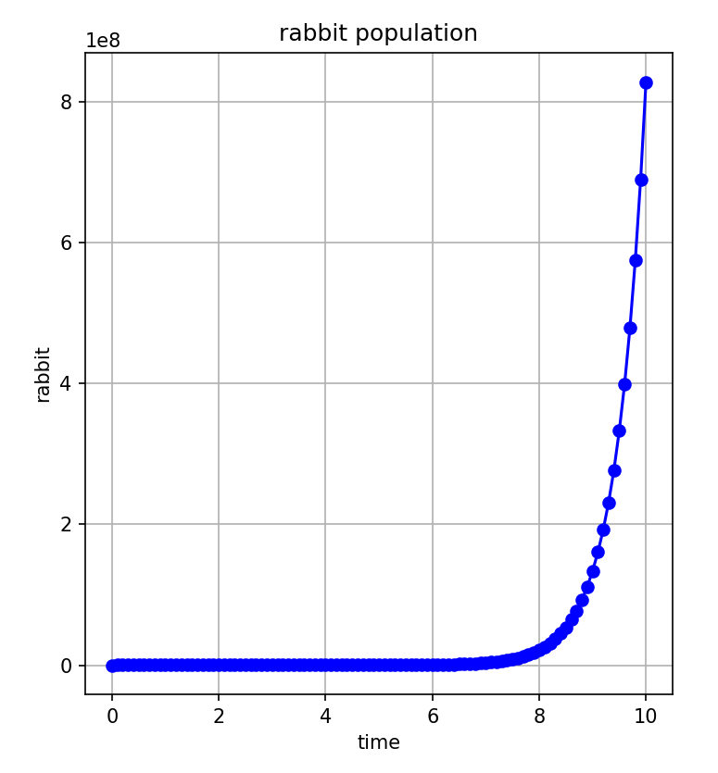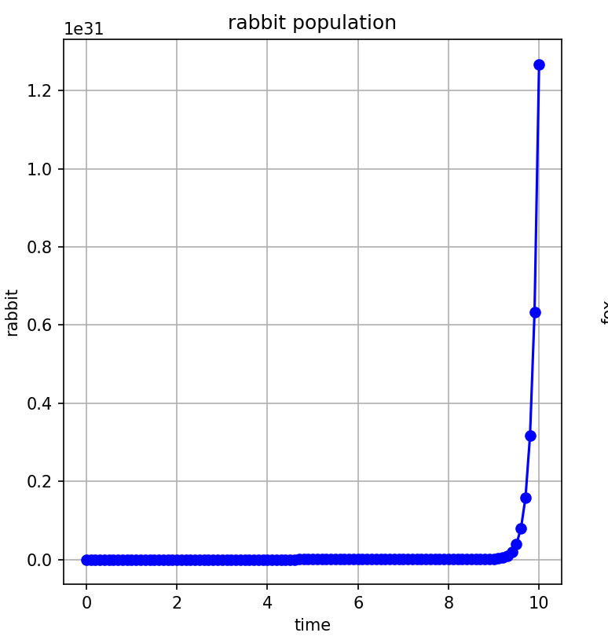

Figure\_3 and Figure\_4:

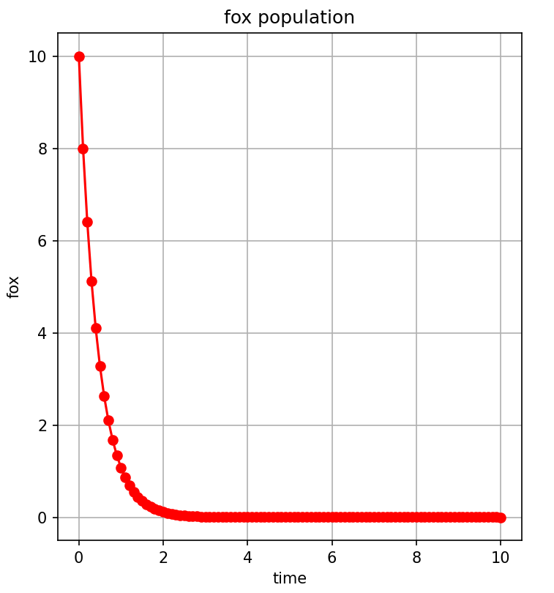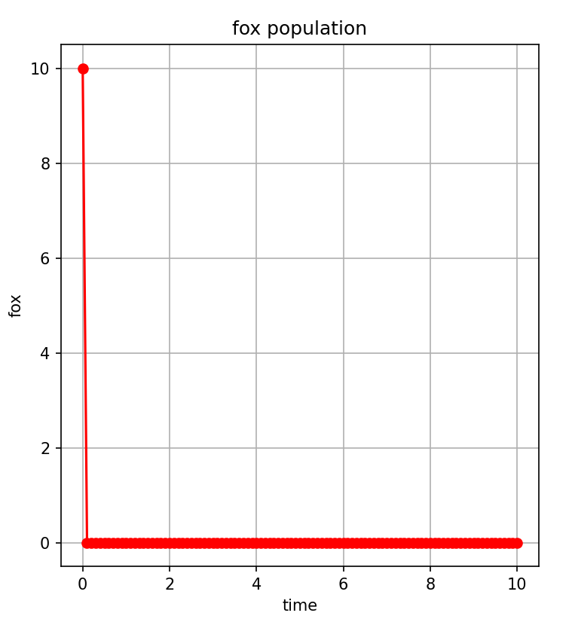

Figure\_5 and Figure\_6:

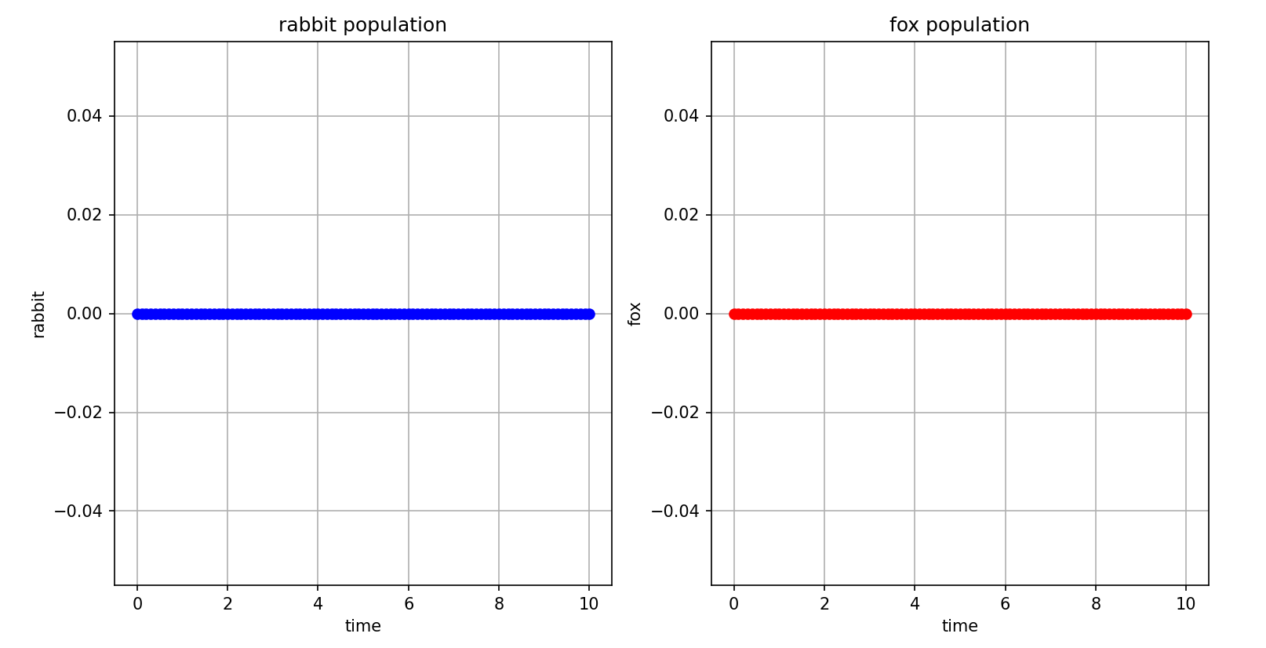

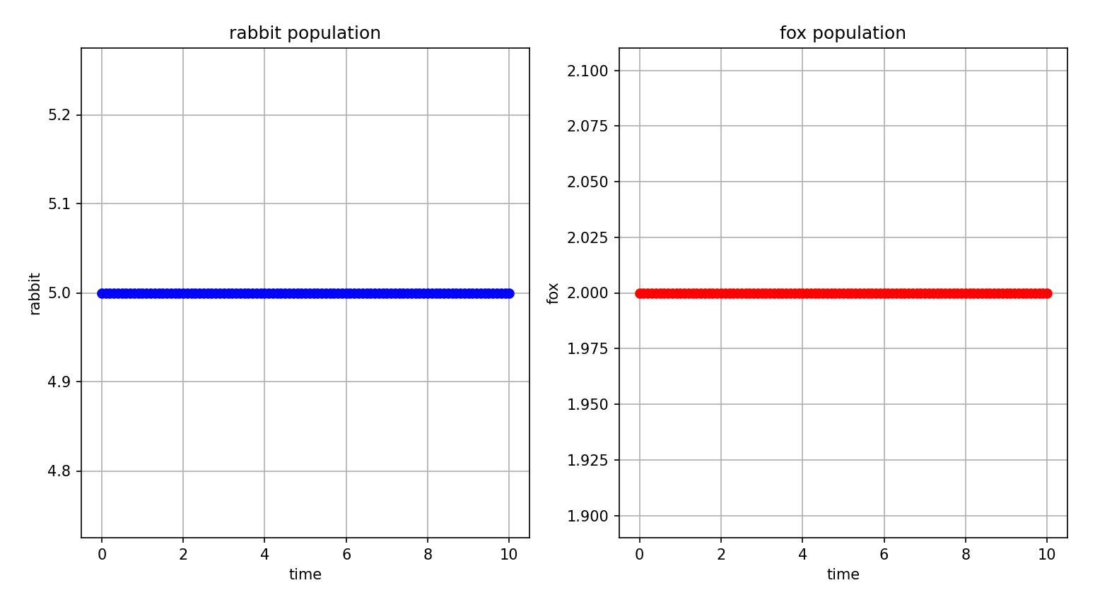

Figure\_7 and Figure\_8

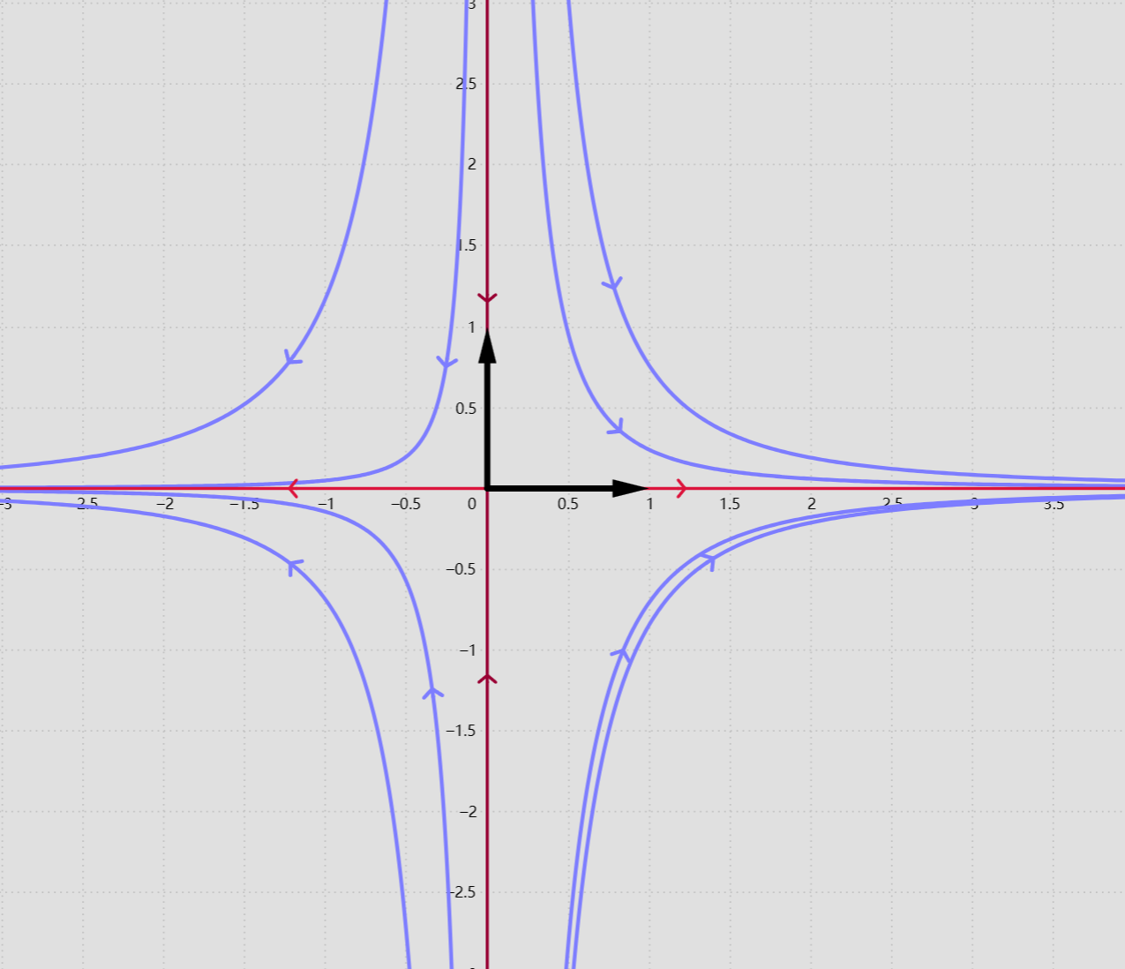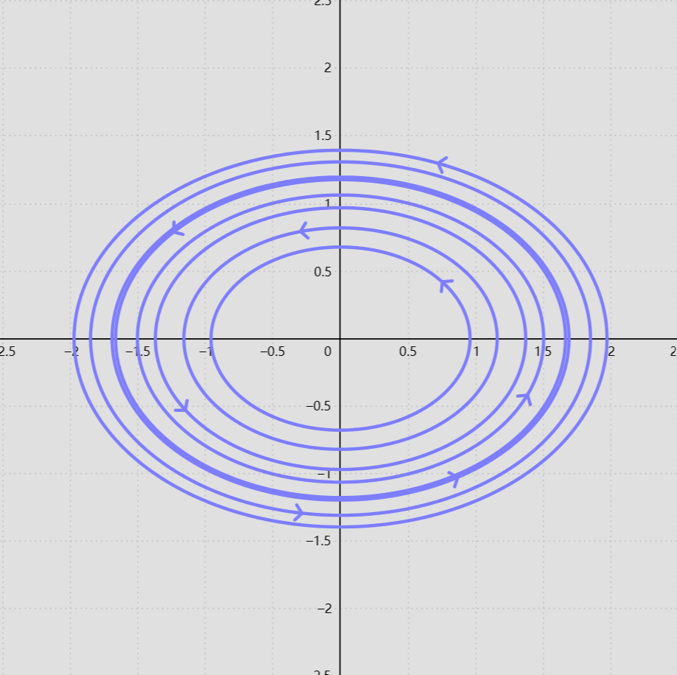

Figure\_9 and Figure\_10:

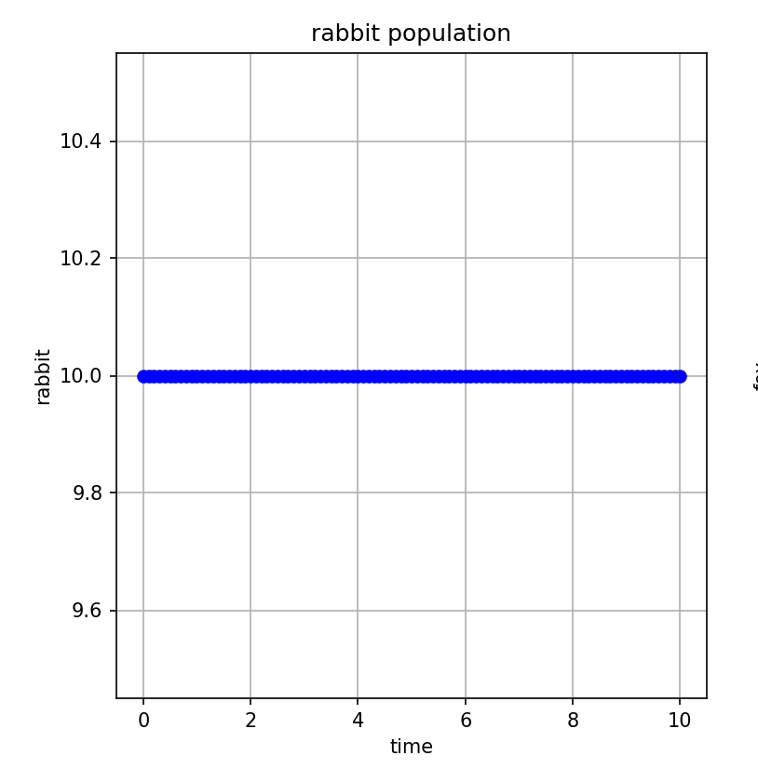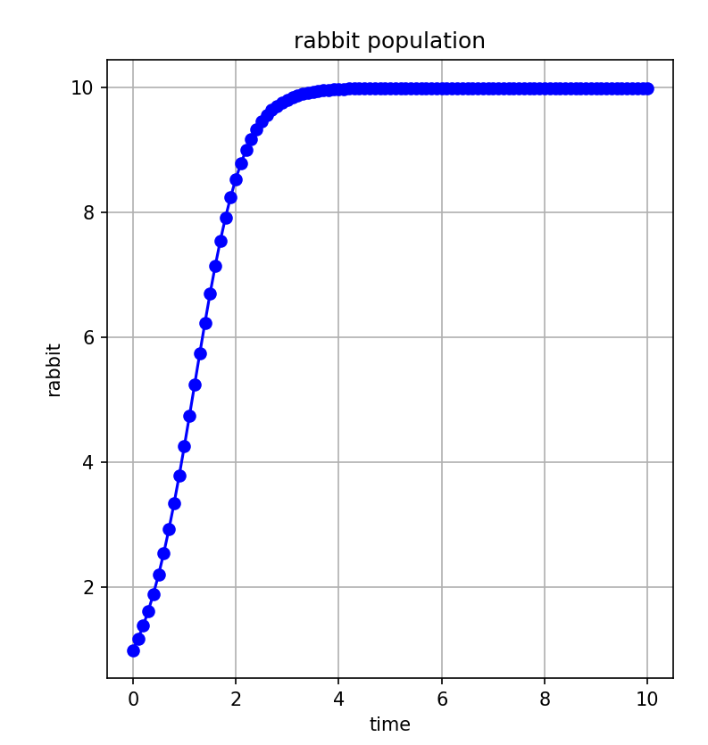

Figure\_11 and Figure\_12:

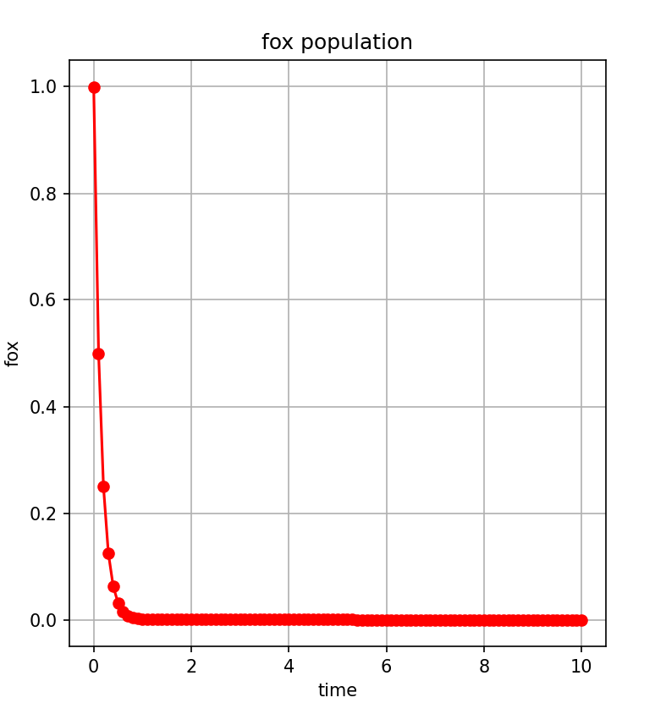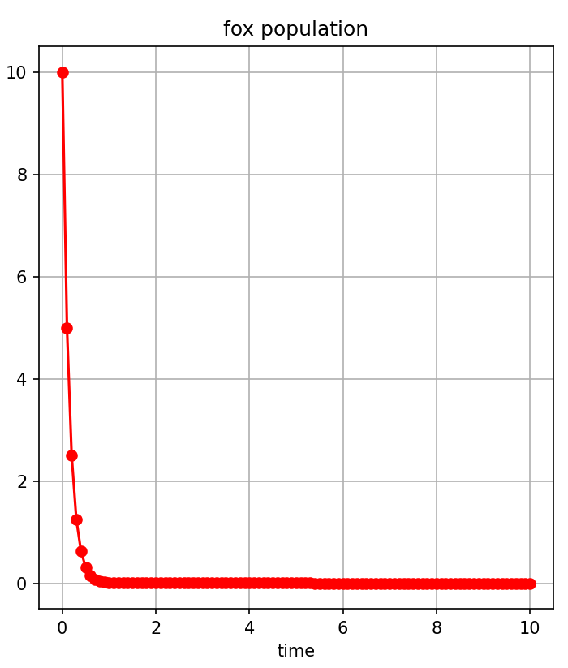

Figure\_13 and Figure\_14

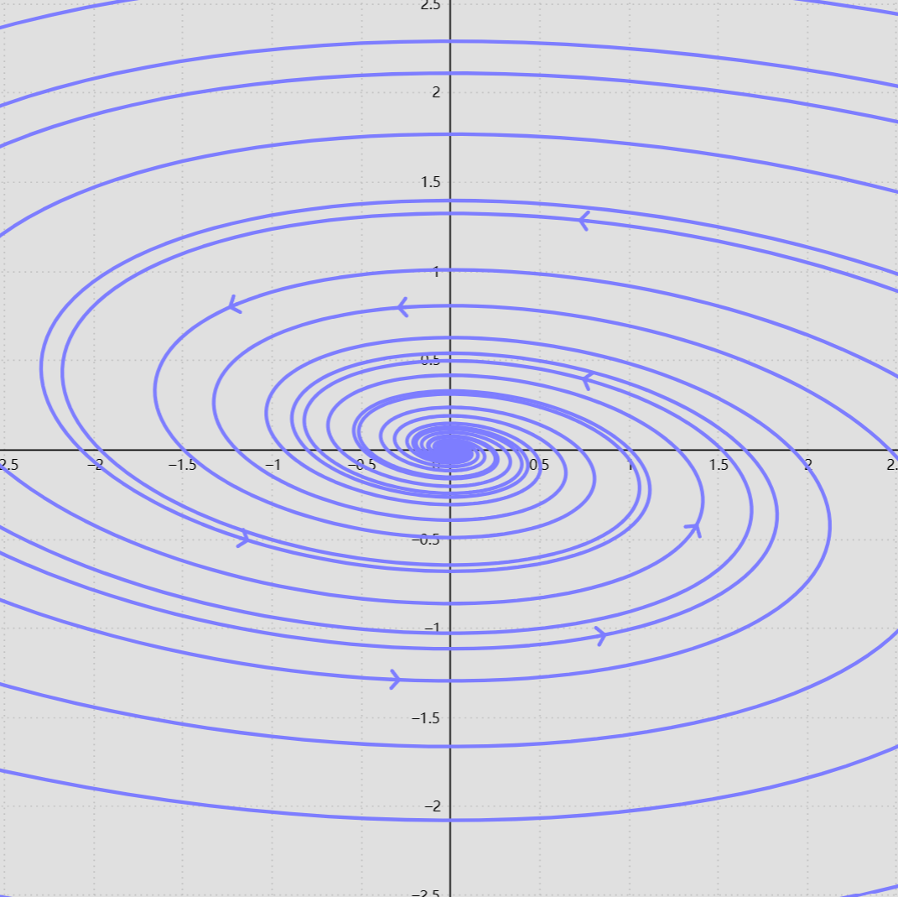

Figure\_15 and Figure\_16

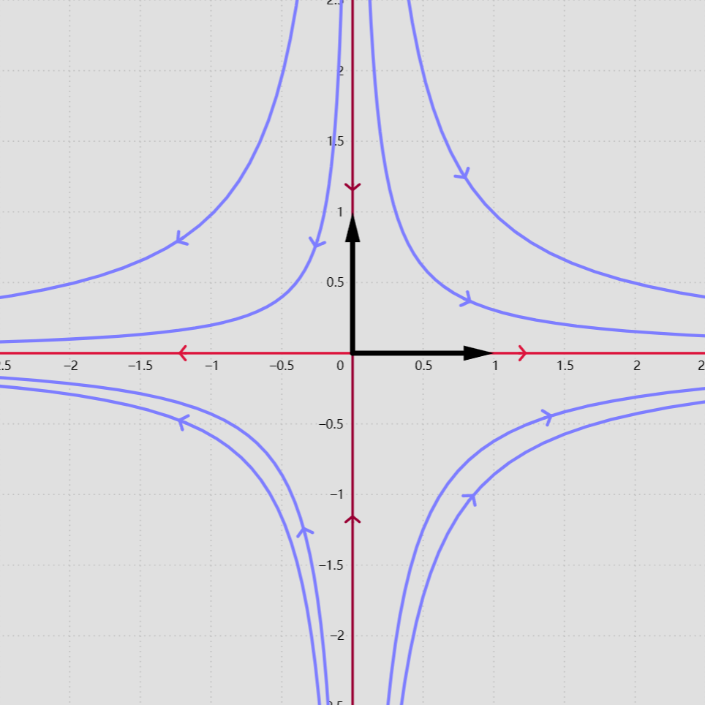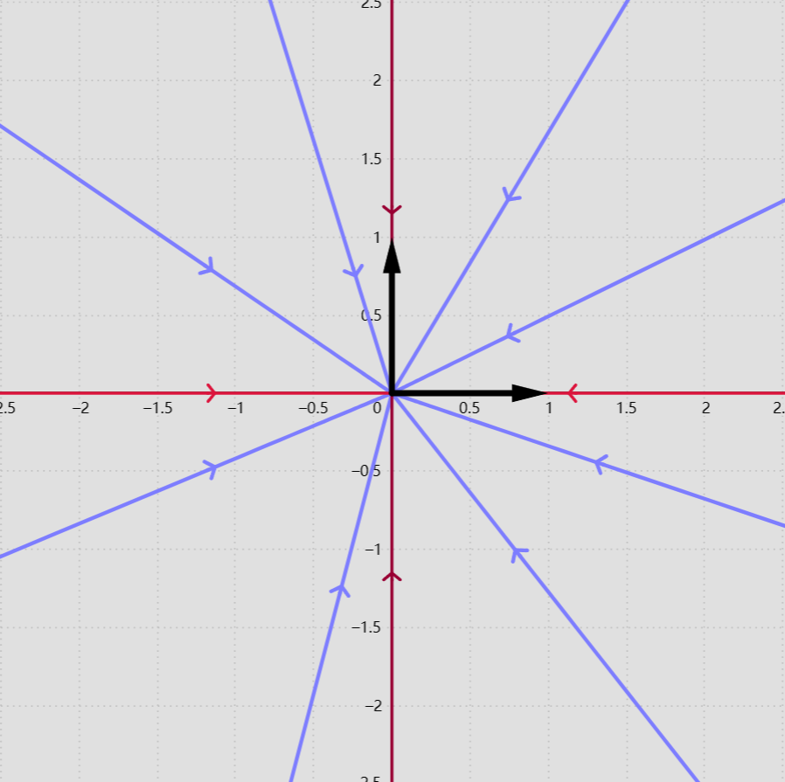

Figure\_17 and Figure\_18

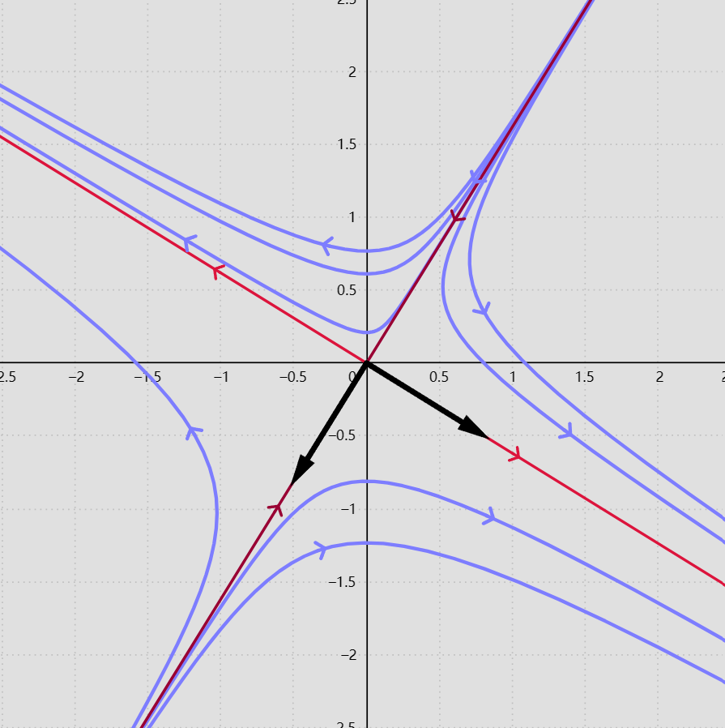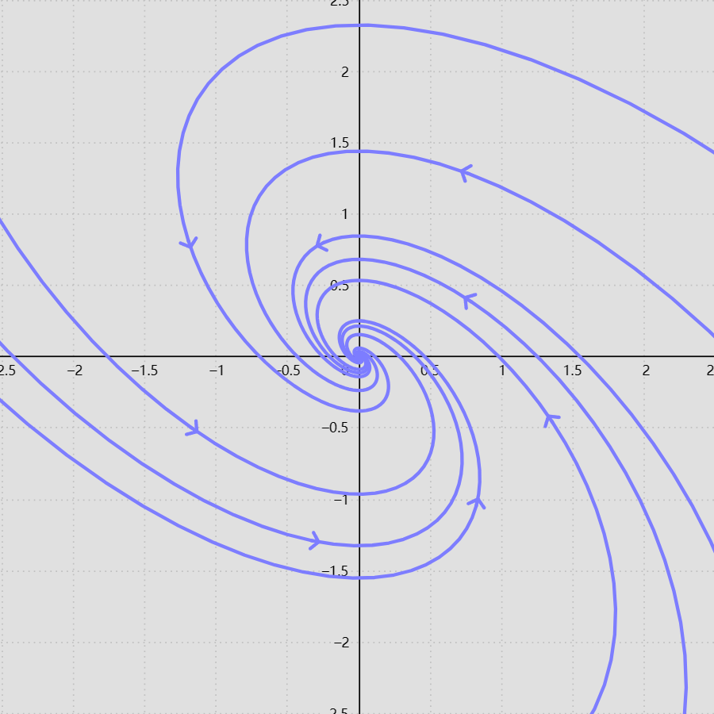

Figure\_19

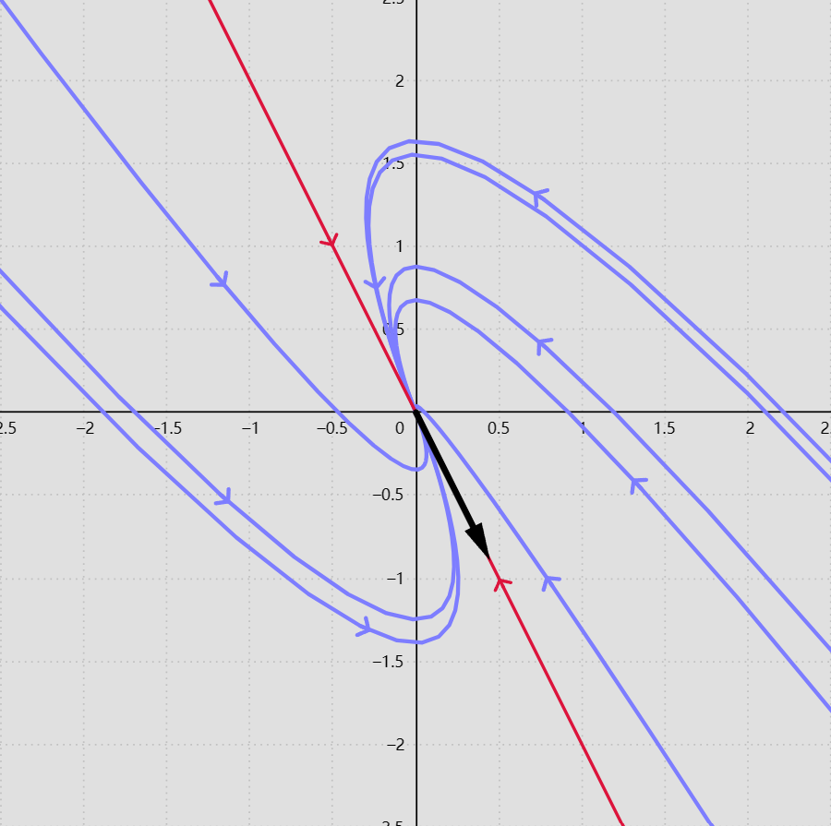

Figure\_20

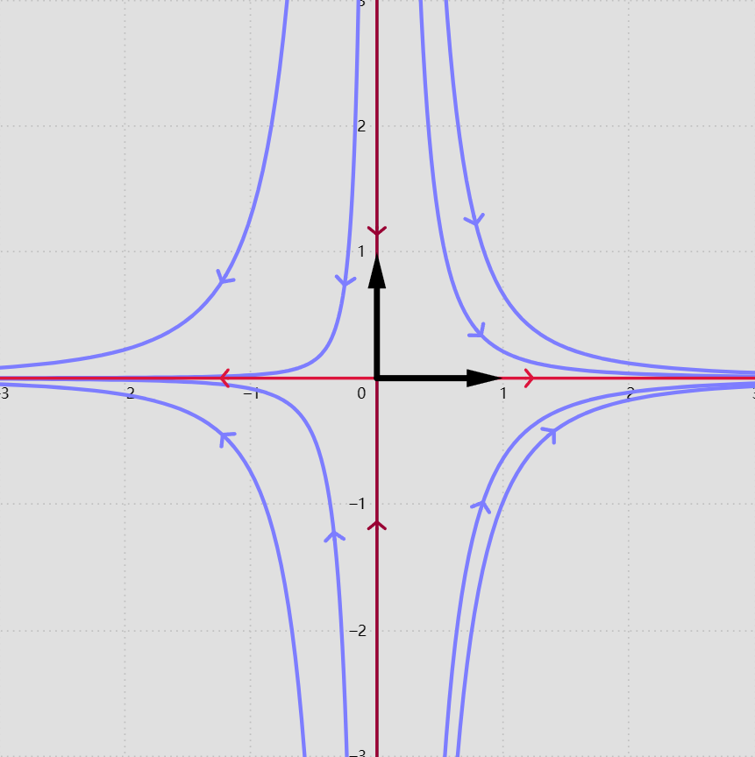

Figure\_21 and Figure\_22

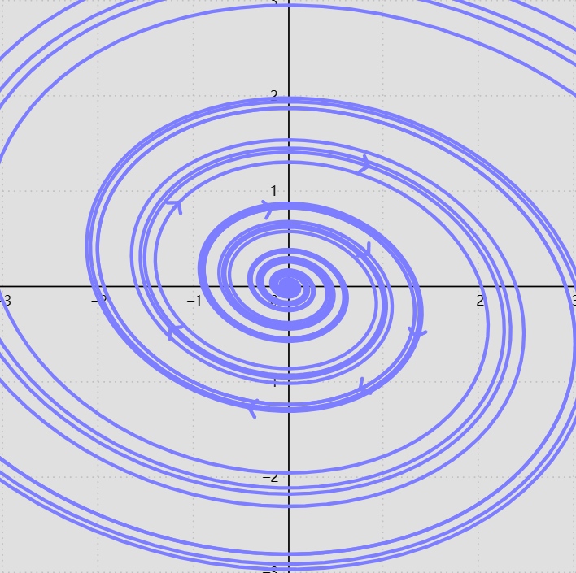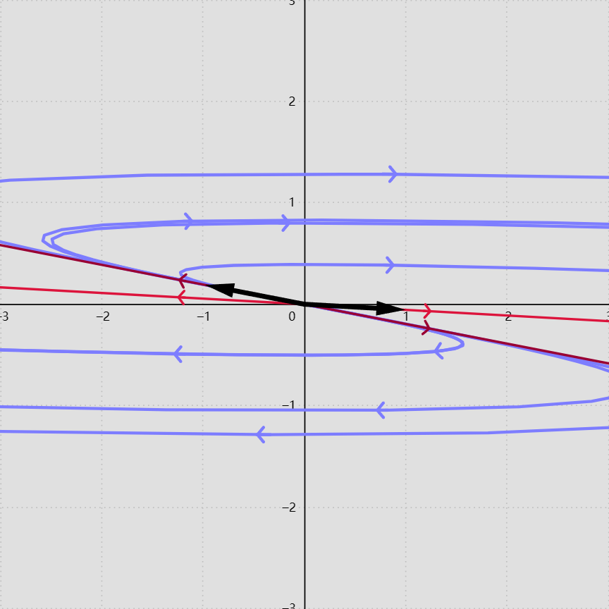

Figure\_23 and Figure\_24

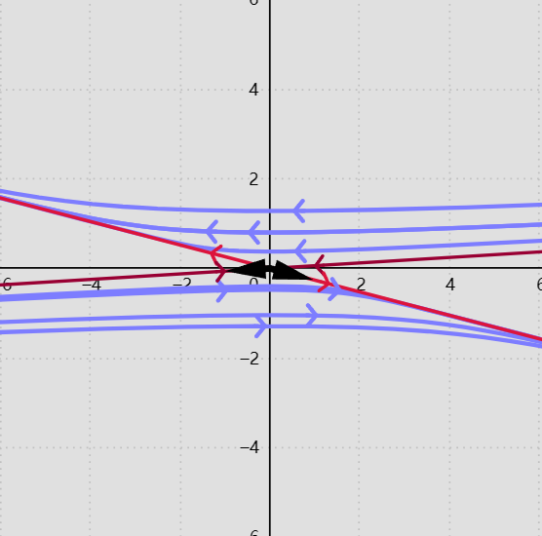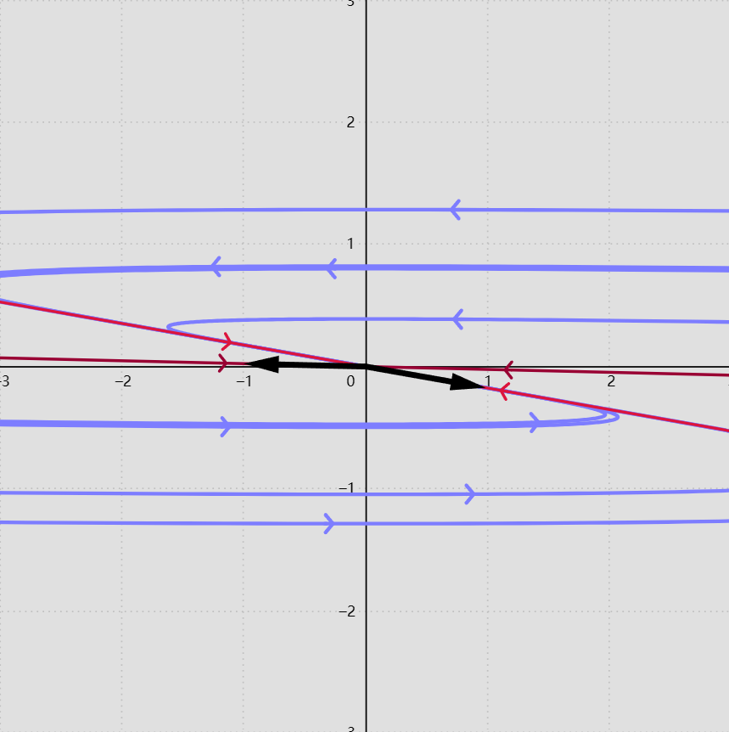

Figure\_25

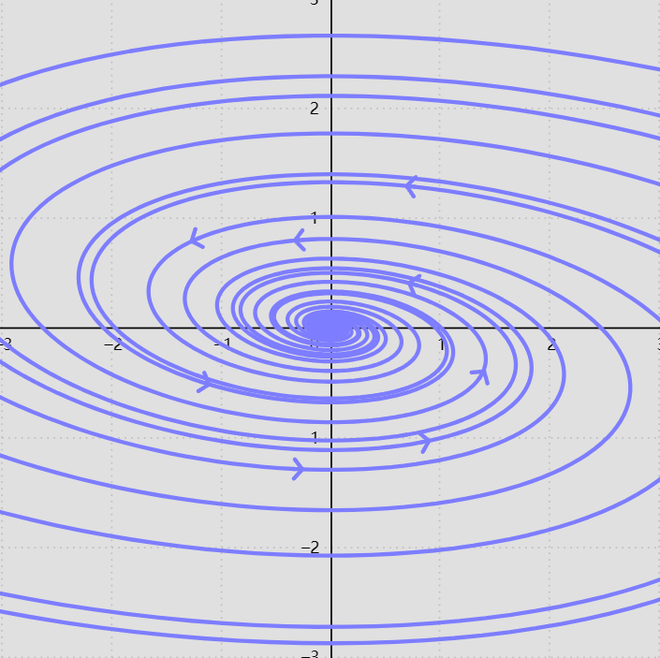

# Citation List

1. Fadugba, Sunday, Bosede Ogunrinde, and Tayo Okunlola. "Euler’s Method for Solving Initial Value Problems in Ordinary Differential Equations." Euler’s Method for Solving Initial Value Problems in Ordinary Differential Equations 13.2 (2012): 1-7.
2. Chandio, M. S., and A. G. Memon. "Improving the Efficiency of Heun’s Method." Institute of Mathematics and Computer Science, University of Sindh, Jamshoro, 76080, 2010.
3. Hanna, O. T. "New Explicit and Implicit 'Improved Euler' Methods for the Integration of Ordinary Differential Equations." Department of Chemical and Nuclear Engineering, University of California, Santa Barbara, CA 93106, U.S.A., 1988.